MDM - MGSS Bulk Data Extracton and TRANFER TOOL Test cases
Prepared by SoftClouds Team
Contents
1. User System Access Test Cases 3
2. Auto Schedule Process Test Cases 5
2.1 Export and Transfer Job Success Scenario Test Cases 8
2.2 Export and Transfer Job Failure Scenario Test Cases 12
3. Delta Data Extract Test Case 14
4. Run On Demand Job Schedule Process Test Cases 22
5. Reset Full Data Extract Button Feature 24
6. For Reset Delta Data Update Button Feature 26
7. Bosch Related Test Cases 30
8. Content Validation Test Cases 31

MGSS Bulk data extraction and Transfer SIT Test Cases
- SIT Test Case Summary:
SIT Attempt | Test Cases Processes | No. of Test Cases | No. of Success | No. of failure | Status
1 | User System Access | 2 | 2 | 0 | Passed
1 | Auto Schedule Process | 8 | 8 | 0 | Passed
1 | Delta Data Extract Process | 3 | 3 | 0 | Passed
1 | Run On Demand Job Schedule Process | 2 | 2 | 0 | Passed
1 | Reset Full Data Extract Button | 2 | 2 | 0 | Passed
1 | Reset Delta Data Extract Button | 3 | 3 | 0 | Passed
1 | Bosch Related Test cases | 3 | 0 | 0 | Not Started, Will be performed by Bosch Team
1 | Sample Content Validation | 1 | 1 | 0 | Passed
 | Total | 24 | 21 | 0

- BRD vs SIT Cases Mapping
# | BRD REQ# | SIT TEST Case# | Remarks
1 | REQ.001 | SIT.0002
2 | REQ.002 | SIT.0008 | It’s a content validation part after Transferring content on OCI Storage listed in SIT.0008 test case. Tool should be extracting data as per requirement
3 | REQ.003 | SIT.0008 | It’s a content validation part after Transferring content on OCI Storage listed in SIT.0008 test case. Tool should be extracting data as per requirement
4 | REQ.004 | SIT.0008, SIT.00023 | It’s a content validation part after Transferring content on OCI Storage listed in SIT.0008 test case. Tool should be extracting data as per requirement
5 | REQ.005 | SIT.0008 | It’s a content validation part after Transferring content on OCI Storage listed in SIT.0008 test case. Tool should be extracting data as per requirement
6 | REQ.006 | SIT.0008 and SIT.00012 | It’s a content validation part after Transferring content on OCI Storage listed in SIT.0008 test case. Tool should be extracting data as per requirement
7 | REQ.007 | SIT.0003, SIT.0004, SIT.00014
8 | REQ.008 | SIT.0008, SIT.00021 | Azure Blob storage screen shot is not available
9 | REQ.009 | SIT.0008, SIT.00021, SIT.00022 | Updated the SIT.00021 to delete the delta data folder content. Azure Blob storage screen shot is not available
10 | REQ.010 | SIT.0007, SIT.0008 | Extracted and Transferred content can be validated via MDM Job report OR via transferred content on OCI storage
11 | REQ.011 | SIT.00021, SIT.00022
12 | REQ.012 | SIT.0008 and SIT.00011 | Content validation is required however tool will behave as per requirement
13 | REQ.013 | SIT.0009, SIT.00010 | It includes data issue and system issue use cases however BRD requirement seems specific to system issue.
14 | REQ.014 | SIT.0002, SIT.0003, SIT.00014, SIT.00013 | SIT.00013 can be tested if new model is added in MD Carline and that particular model should be visible automatically in this tool with default scheduling timestamp based on other existing models schedule timestamp.
15 | REQ.015 | SIT.0005, SIT.0006, SIT.0007
16 | REQ.016 | SIT.0007, SIT.0008
17 | REQ.017 | SIT.00014, SIT.00015
18 | - | SIT.00016 , SIT.00017, SIT.00018, SIT.00019, SIT.00020 | These test cases related requirements are added to support running business and support operations. BRD will be updated for these requirements as needed.

User System Access Test Cases
- Users should be able to login into MDM using below URL for applicable environment:
Dev : https://na.dev.mgss.customerservice.mazda.com/okmdmgt/mypage
SIT: https://na.test.mgss.customerservice.mazda.com/okmdmgt/mypage
QA: https://na.qa.mgss.customerservice.mazda.com/okmdmgt/mypage
PROD: https://na.mgss.customerservice.mazda.com/okmdmgt/mypage
Expected Result: User should be able to view below MDM application Landing Page and should be able to view “MGSS Bulk Data Export and Transfer Tool” on MDM Landing Page.
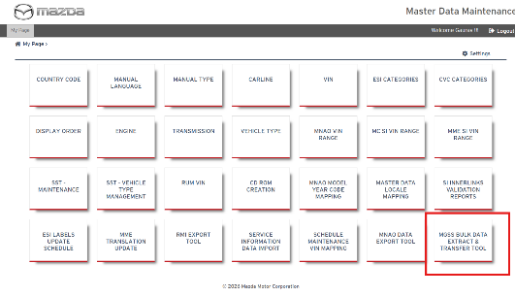
Status: Pass
Remarks: SIT passed and User can view module based on MDM roles and permission only. Currently , this module access is provided for “MDM MazdaAce Admin” role only.

- User will click on “MGSS Bulk Data Extract and Transfer Tool” title on Landing page
Expected Result: User should be able to view below page which shows schedule setting and Models available for auto schedule / on Demand where Model Year is >=2012 Year in MDM Carline data for en_US locale.

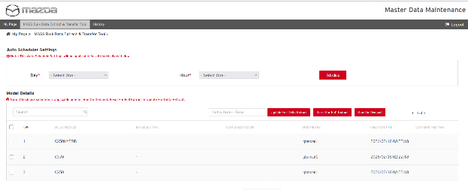
Status: Pass
Remarks: N/A

Auto Schedule Process Test Cases
- Users should be able to set the schedule for all models using schedule setting where users set the day and hour to auto trigger the monthly job extraction.
Expected Result:
Once schedule setting is set, user will view the message “schedule details have saved successfully” given in above screenshot.
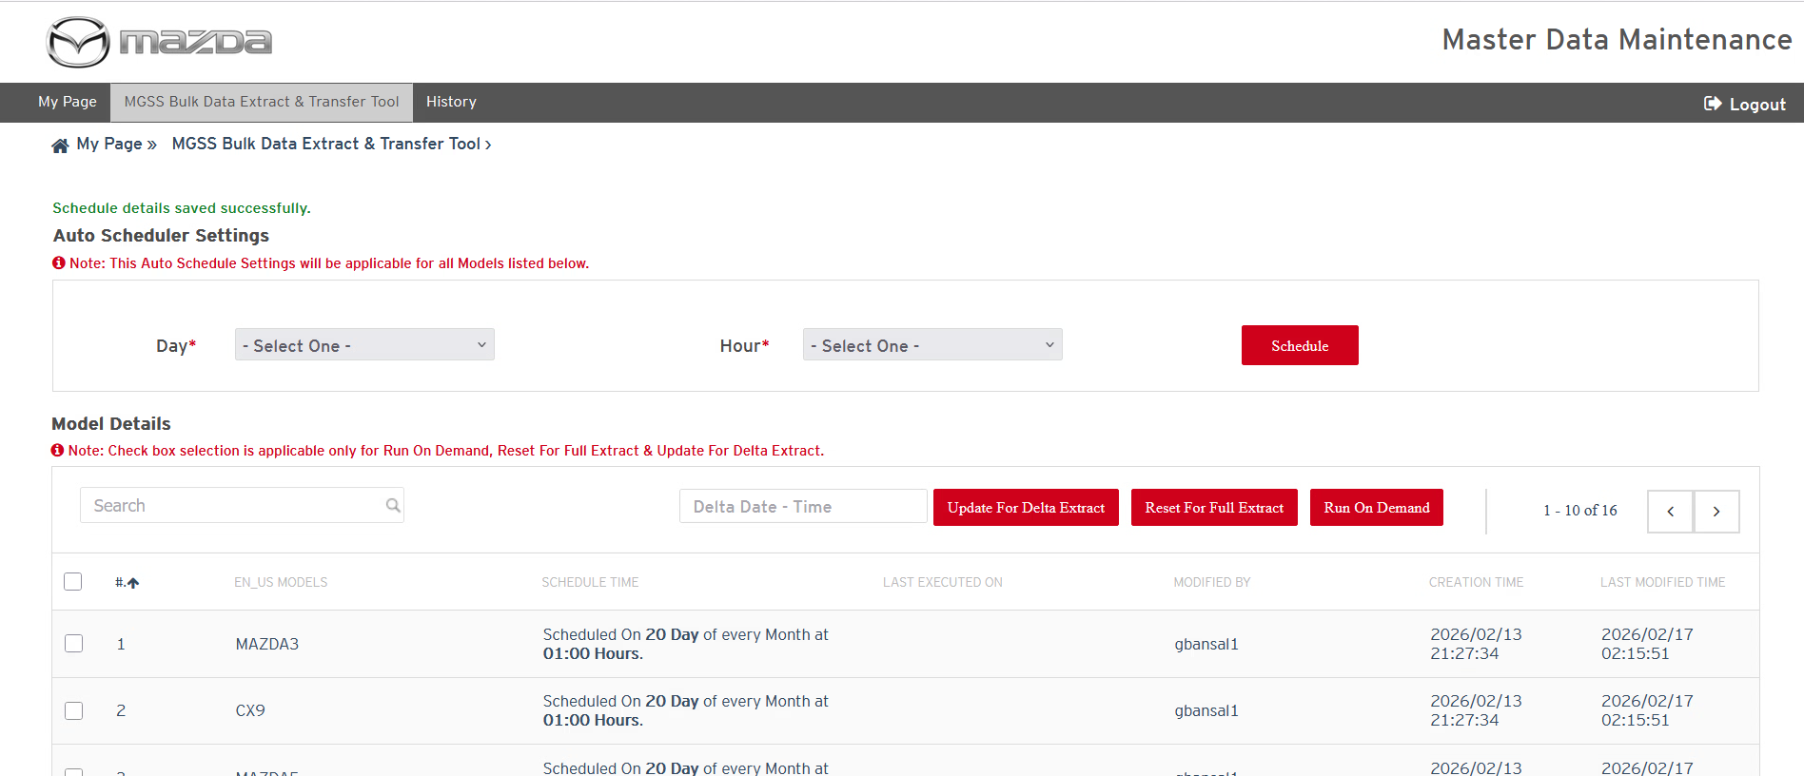
Note: Scheduler job triggers in every hour to verify the latest schedule timing. Whenever user set the schedule, so user needs to make sure that schedule timing and scheduler job is having min. one hour difference to auto trigger the monthly data extraction job.
Status: Pass
Remarks:
- User should be able to view the latest schedule time for every model in below list of Model in “Schedule Time” column.
Expected Result:
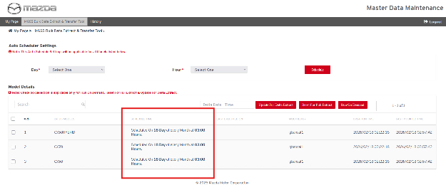

Status: Pass
Remarks:

- Once the auto scheduler job is triggered, system will start data extraction based on “Last Executed On” date time stamp provided on “MGSS Bulk data extract and transfer Tool” page. If the “Last Executed On” is blank or “-“ then system will extract full data of that model else delta data extraction will be performed by system from last executed on time to till current job start date and time and then User should be able to view the Extraction job record in “History Page” for all models with naming conventions “MGSS_ModelName_EXT_JobId”.
Note: “Last Executed On” timestamp is updated only when job running status is completed and Data status is “Success” or “Data Issue”. Incase of Job running status = Aborted and data status = “System issue” then it does not update or override the “Last executed On” timestamp.
Expected Result:

LAST EXECUTED ON Page
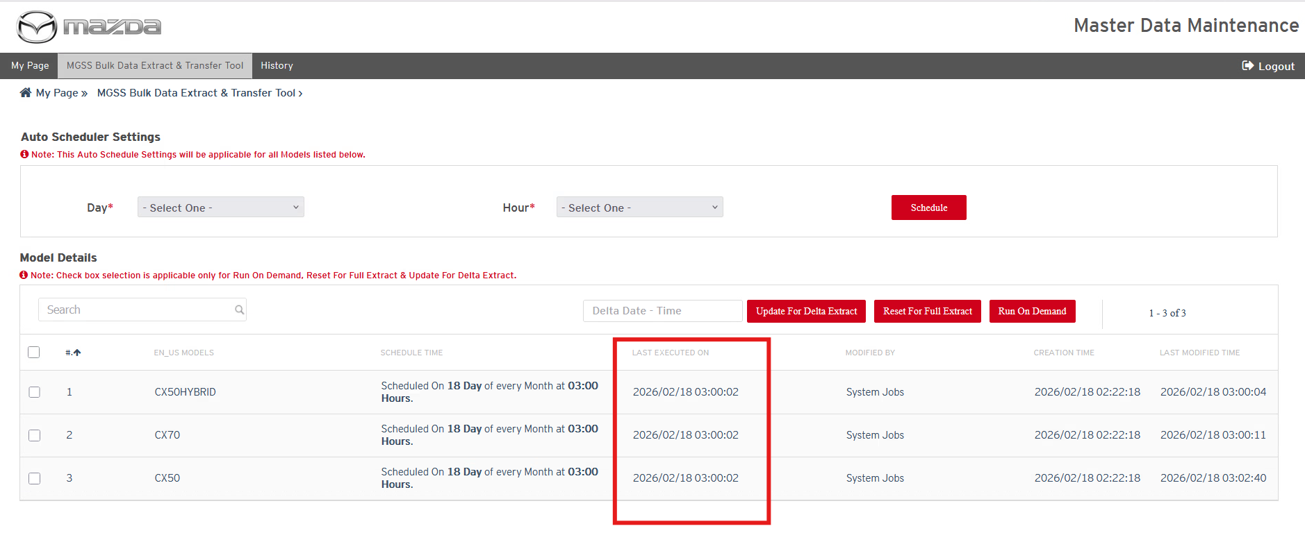
Job History page
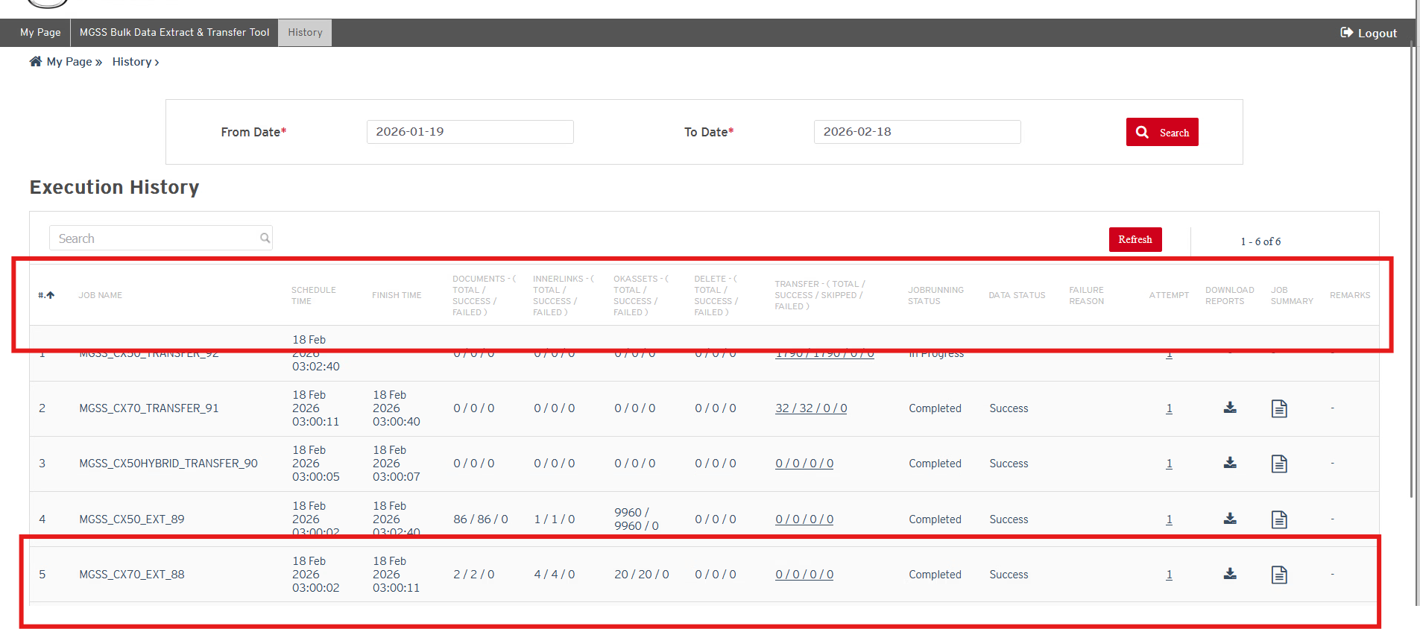
Note: Every model should have one record of data extraction with following details:
- Job schedule time
- Finish time
- Documents [Total/ Success/ Failed]
- Inner Links [Total/ Success/ Failed]
- OKAssets [Total/ Success/ Failed]
- Delete [Total/ Success/ Failed]
- Running Status [In Progress, Complete, Aborted]
- Data Status [Success/ Failure] only incase of In Complete
- Failure Reason [Data Issue, System Issue, or blank with hyphen “-“if Data status is Success] only in case of Data Status is Success Or failure
- Attempt [It shows no. of attempts performed by Job for data extraction]
- Download Reports
- Job Summary
- Remarks – it will be available only incase of system issue.
Status: Pass
Remarks:
- If user finds the Job Running Status “In Progress” , it means that content extraction is in progress
Expected Result: One of the following count should be progressing
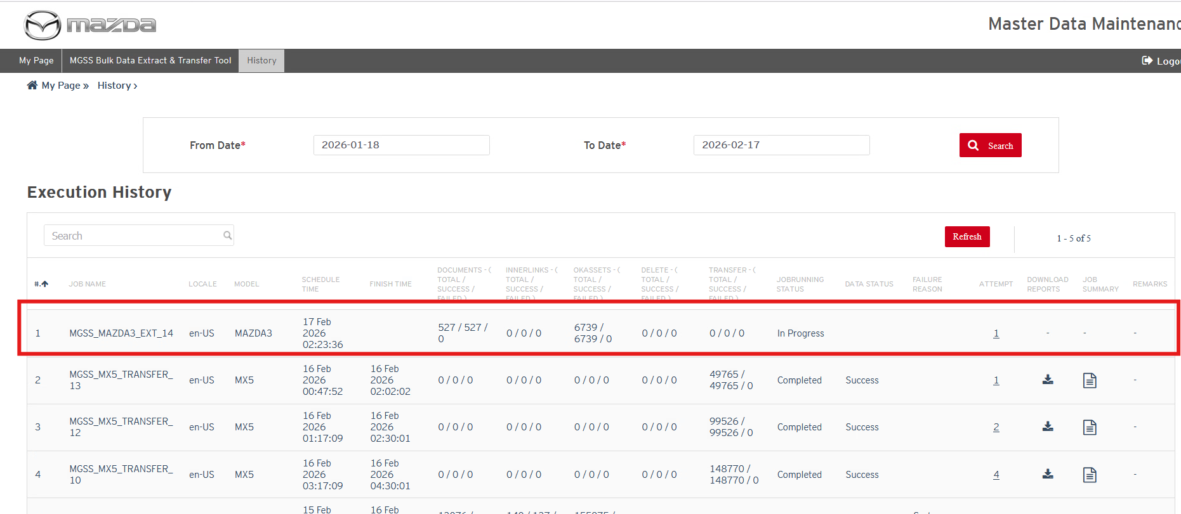
- Documents [Total/ Success/ Failed]
- Inner Links [Total/ Success/ Failed]
- OKAssets [Total/ Success/ Failed]
- Delete [Total/ Success/ Failed]
Status: Pass
Remarks:

2.1 Export and Transfer Job Success Scenario Test Cases
- If Extraction job Running Status “Completed” and Data job status is “Success”, it means that there was no issue in data extraction and transfer job should be started to transfer data from MGSS file server to OCI storage env. User will also get an email notification on extraction Job completion.
Expected Result:
- User should be able to download the reports in MDM history page using “Download reports” for that completed job.
- User should be able to view the extracted data on MGSS file server in required folder structure.
- User should be able to view the transfer job record in “In Progress” status on history page.
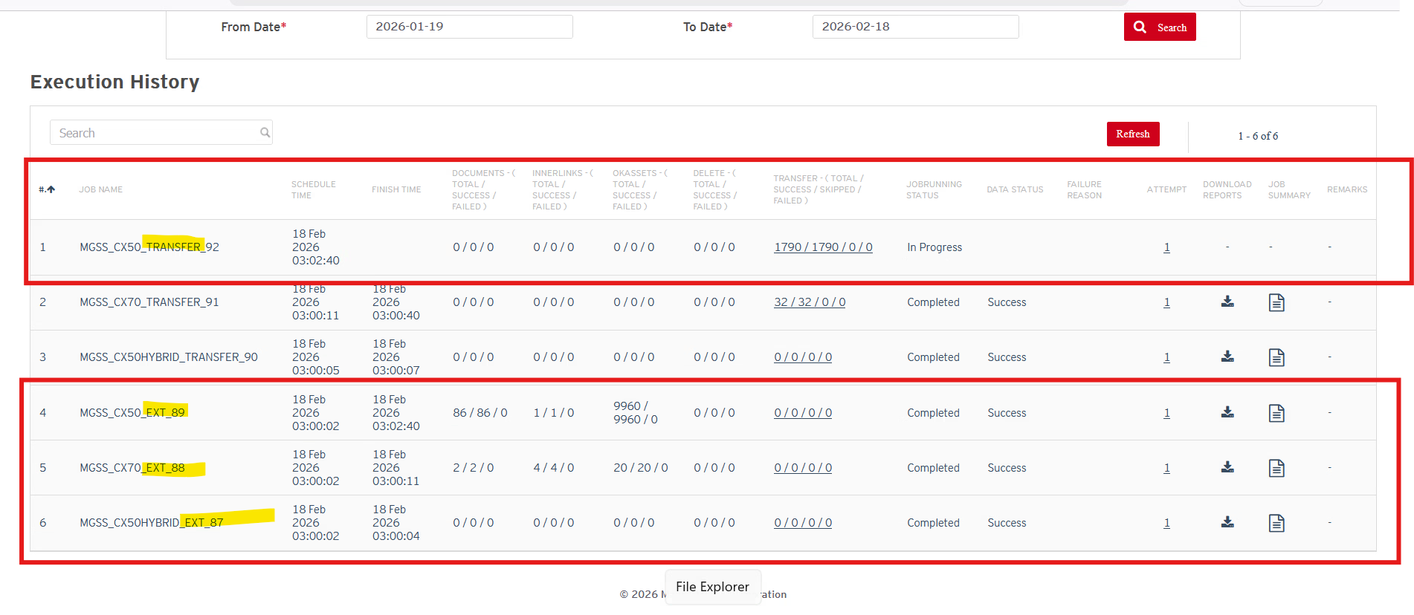
Status: Pass
Remarks:
- If Transfer job Running Status “Completed” and Data status is “Success”, it means that extracted data should be copied on OCI storage “FULL_DATA_TEST” folder and “DELTA_DATA_TEST” folder for Testing purpose.

Note: in UAT and PROD, Expected OCI Folder names are “FULL_DATA and DELTA_DATA”
Expected Result:
- User should be able to view the transfer job status with “Complete” and data status with “Success” on MDM history page and transfer (Total/ Success/ Failed) count updates too which are moved to OCI storage.
- User can download the reports for completed transfer job from MDM history page fr analysis
- Incase job find any unpublished content in MGSS then a delete.csv file will be prepared and provided with extracted content under Full_Data_Test and Delta_Data_Test folders.
- Users can view the transferred content on OCI storage location in required folder structure.
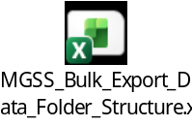

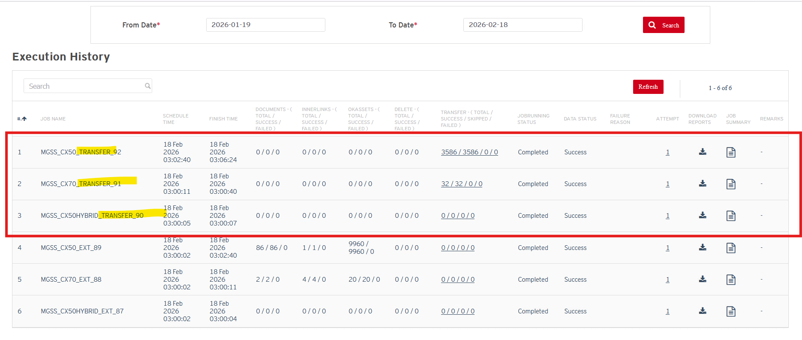
Click on Transfer link to view Transfer summary
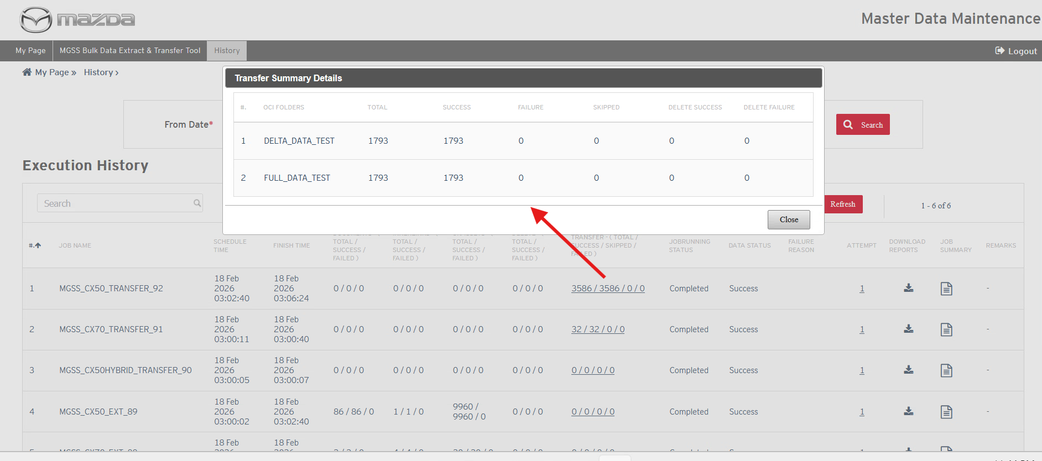
OCI folder storage location for SIT:
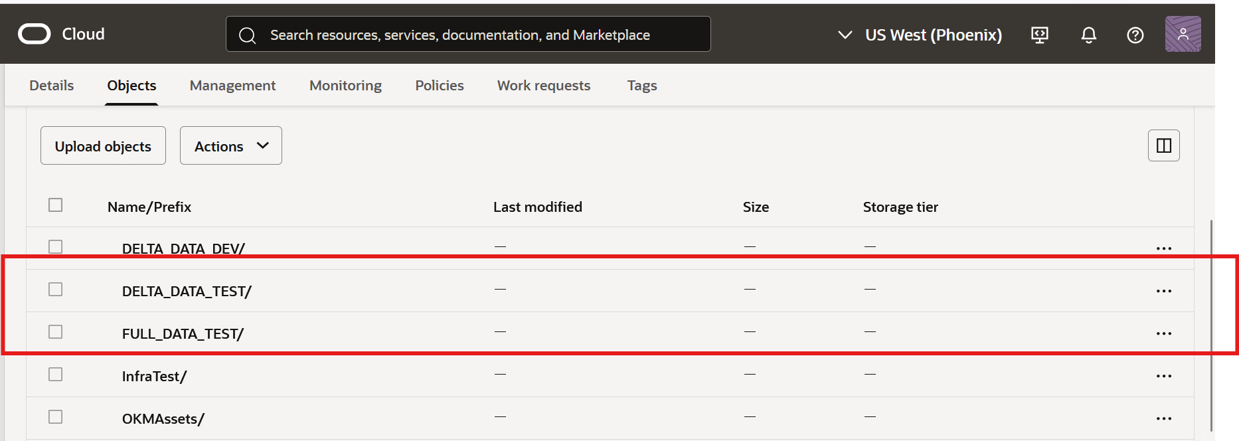
Full_DATA_TEST Folder
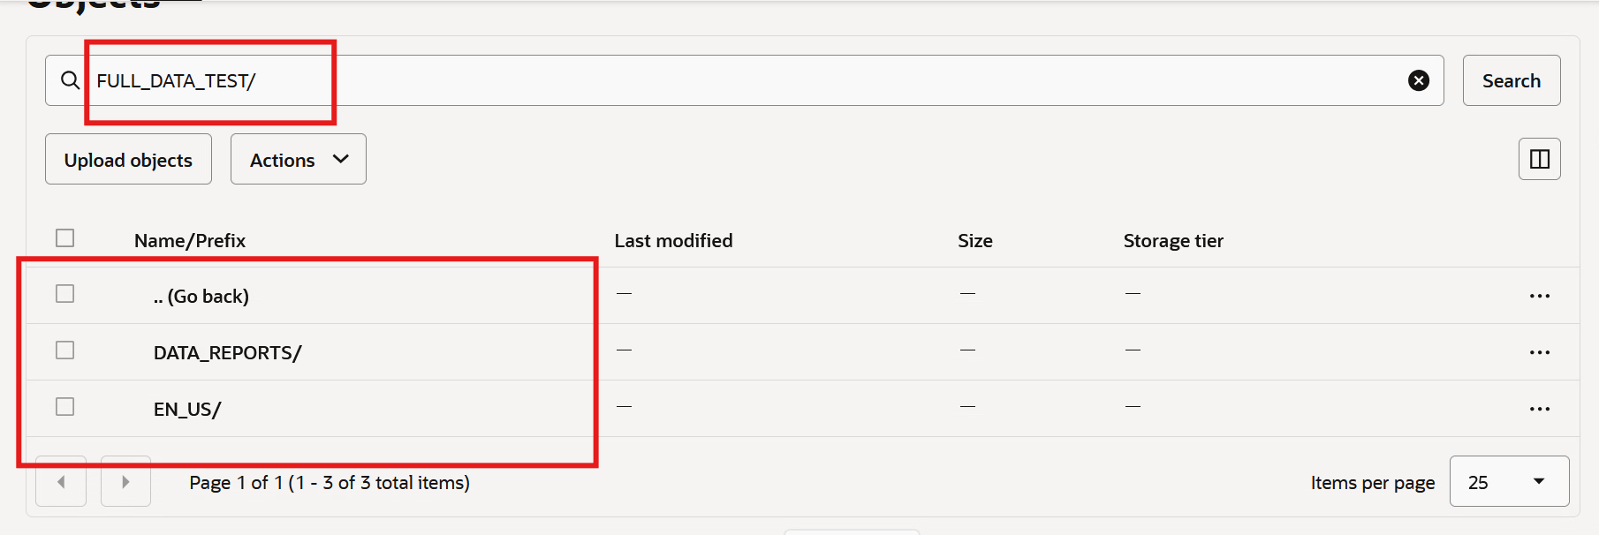

DELTA_DATA_TEST Folder:
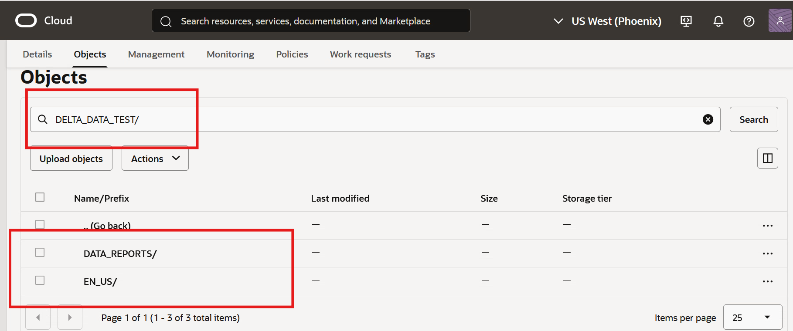

Status: Pass
Remarks:

Export and Transfer Job Failure Scenario Test Cases
- If Extraction job Running Status “Completed” and Data status is “Failure” and Failure reason = “Data issue” then it means that extracted data is having some data issue however, Transfer job will be initiated to transfer data on OCI storage. User will also get an email notification on extraction Job completion.
Expected Result:
- User should be able to download the reports in MDM history page using “Download reports” for that completed job for analysis on data issue and fix it and make it ready for next run or on demand job run.
- User should be able to view the extracted data on MGSS file server in required folder structure.
- User should be able to view the transfer job record in “In Progress” status on history page.
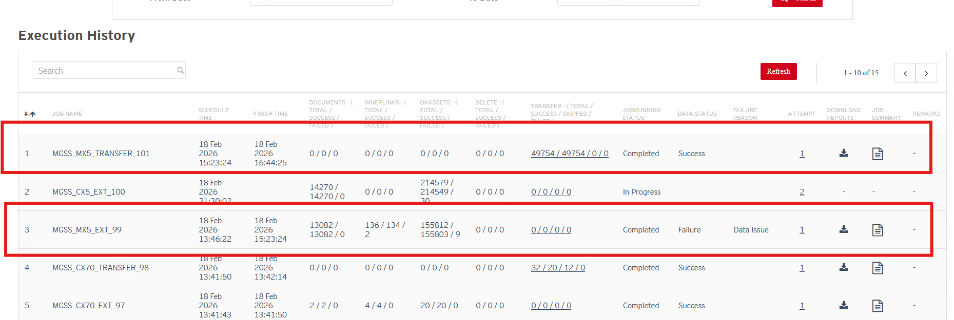
Status: Pass
Remarks:
- If Extraction job Running Status “Aborted”, Data Status = “Failure” and Failure Reason = “System issue”, it means that there was some issue with system during data extraction like Network Issue, Server issue or other technical issue etc. then job will perform reattempt of the data up to 3 times internally. If issue persists then “Running Status=Aborted”, Data Status = “Failure” and Job Failure Reason=” System Issue”.
Expected Result:
User should be able to download the report from MDM History page for particular job to fix the issue with Remarks comment. User may be able to download Reports only incase system issue occurred after report generation else reports may not be available for download in case of system issue.

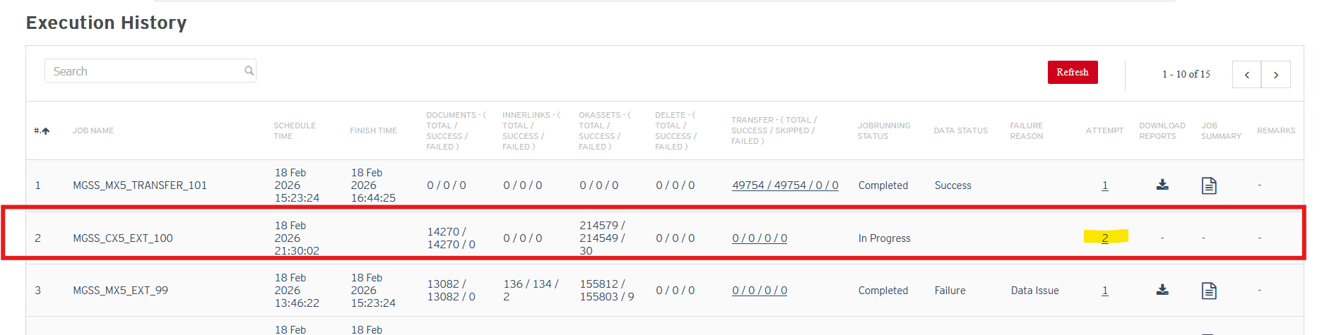

On click on Attempt number then below popup should appear:
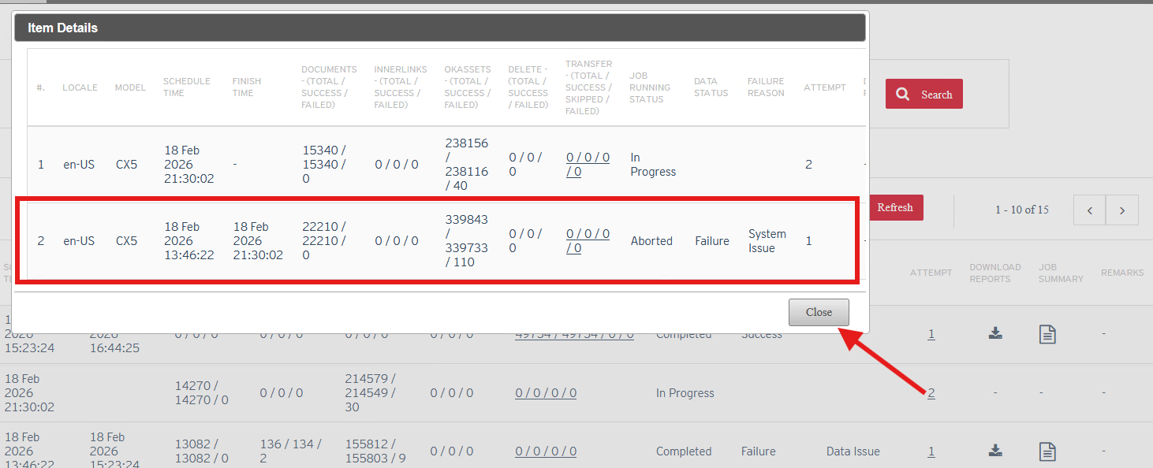
On click on “Remarks”, user should be able to view the pop-up to see the system issue details. Remarks will appear if all job re-attempts are failed like below.
Note: Below screenshot is of older testing results. Could not replicate the same in current SIT env.
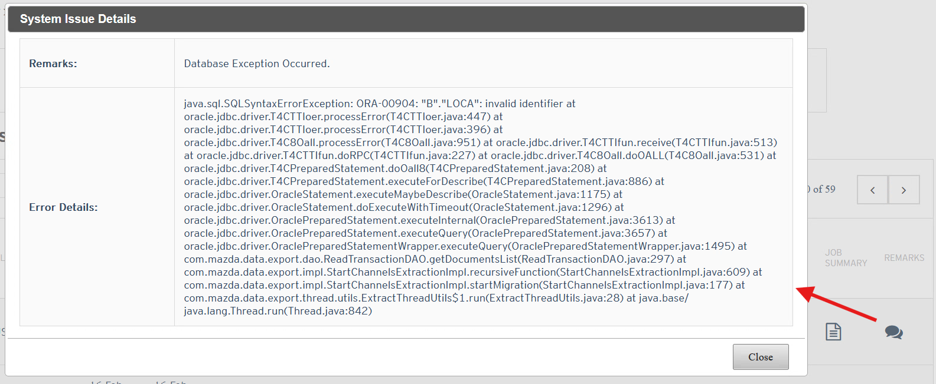
Status: Pass
Remarks:

Delta Data Extract Test Case
- User updates the existing documents or add new documents to existing model for any channel like SI or SM or WD channel where model year is >=2012 then only delta Data extraction and transfer should occur not full data. Content will be merged in FULL_DATA_TEST Folder and a New copy of delta content will be created in “DELTA_DATA_TEST” folder on OCI Storage.
Expected Result:
Existing content in OCI Storage Full_Content_Folder:
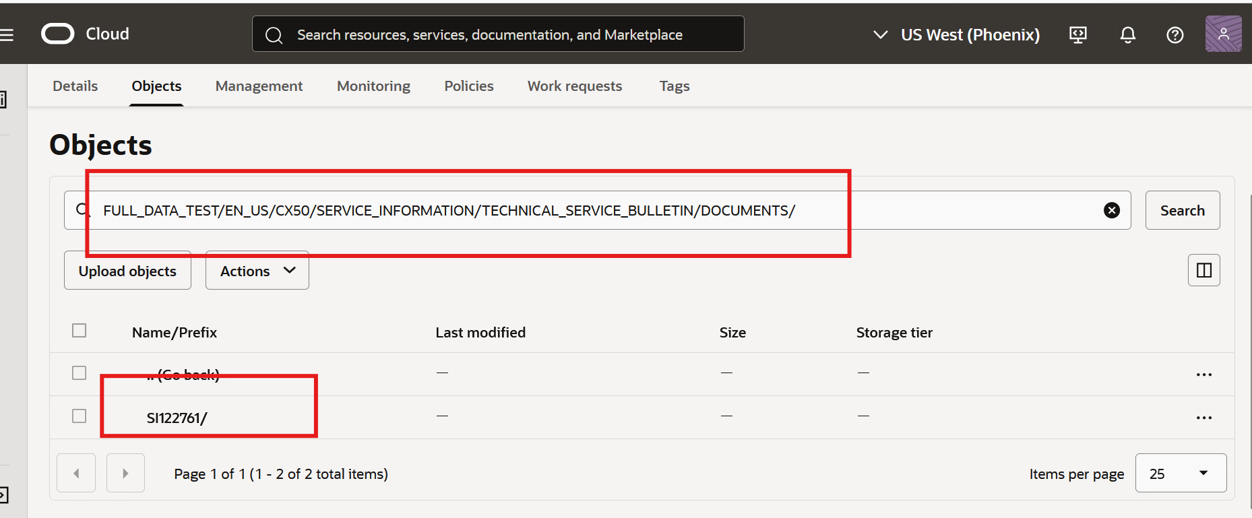

Published one more SI document in IM
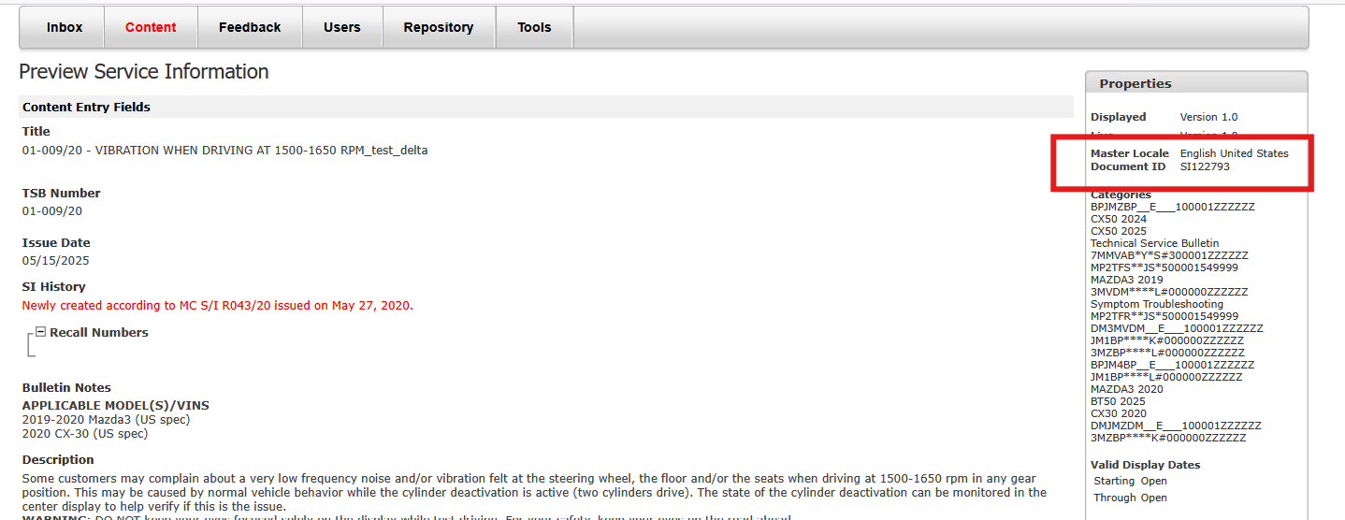

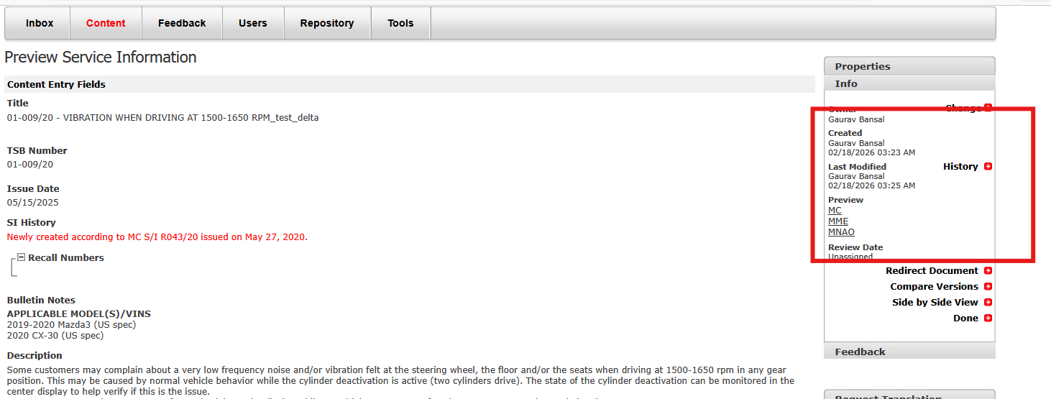

Content Merged in Full_DATA_TEST Folder
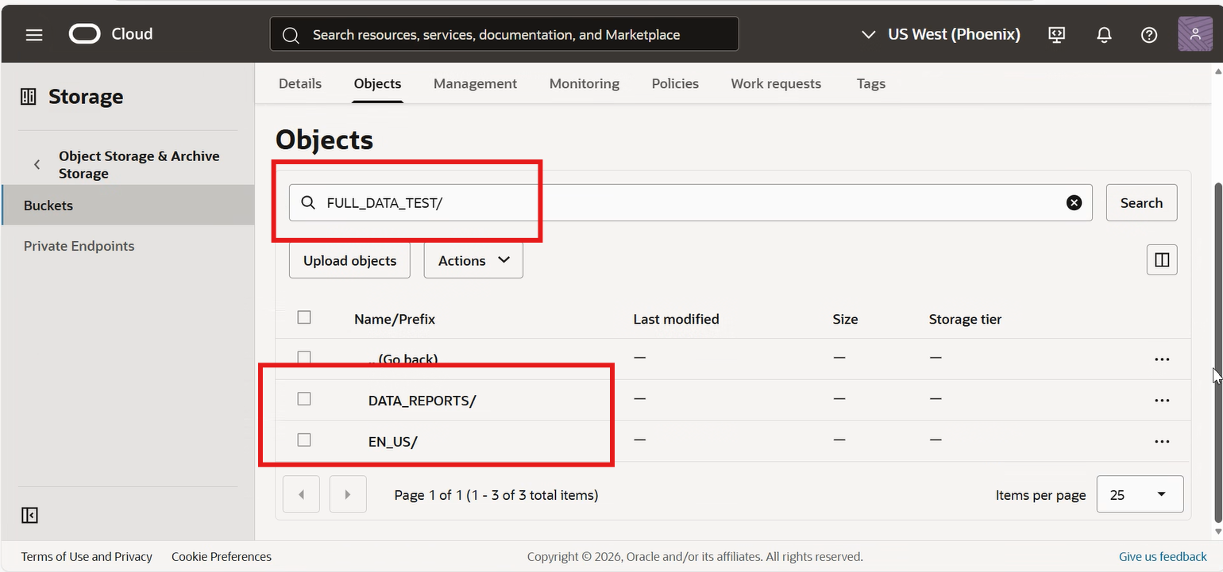

Updated OCI storage for Full_Data_Test and Delta_Data_Test Folder:
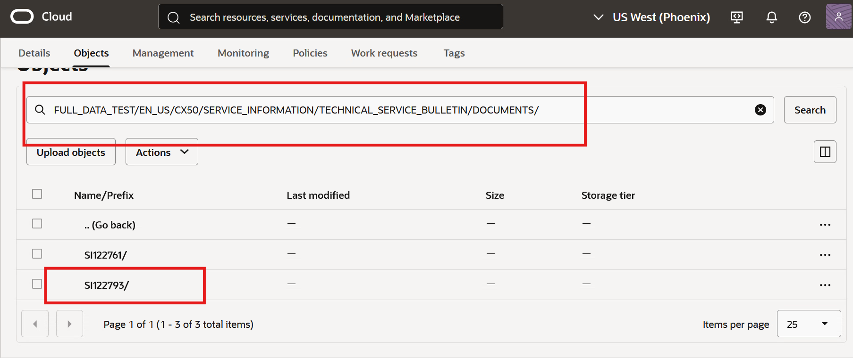
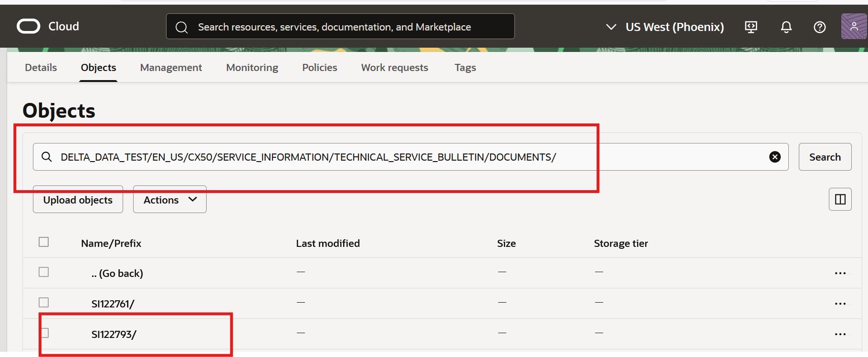

Status: Pass
Remarks:
- After initial full data extract, User unpublish the document for any channel like SI or SM or WD channel where model year is >=2012. Then delete.csv file should be generated in OCI storage Full_Data_Test Folder and Delta_Data_Test Folder. Also, document should be deleted from Full_Data_Test Folder. Delete.csv file will have info like below
File Name | File Path | Unpublished Date
SM10001.xml | en_US/CX5/SERVICE_MANUAL/WM/Documents/SM10001/SM10001.xml | 1/1/2026
SM10002.xml | en_US/CX5/SERVICE_MANUAL/WM/Documents/SM10002/SM10002.xml | 2/2/2026
SM10003.xml | en_US/CX5/SERVICE_MANUAL/WM/Documents/SM10003/SM10003.xml | 3/3/2026

Expected Result:
Existing SI document in OCI storage in Full_Data_Test Folder – SI122761
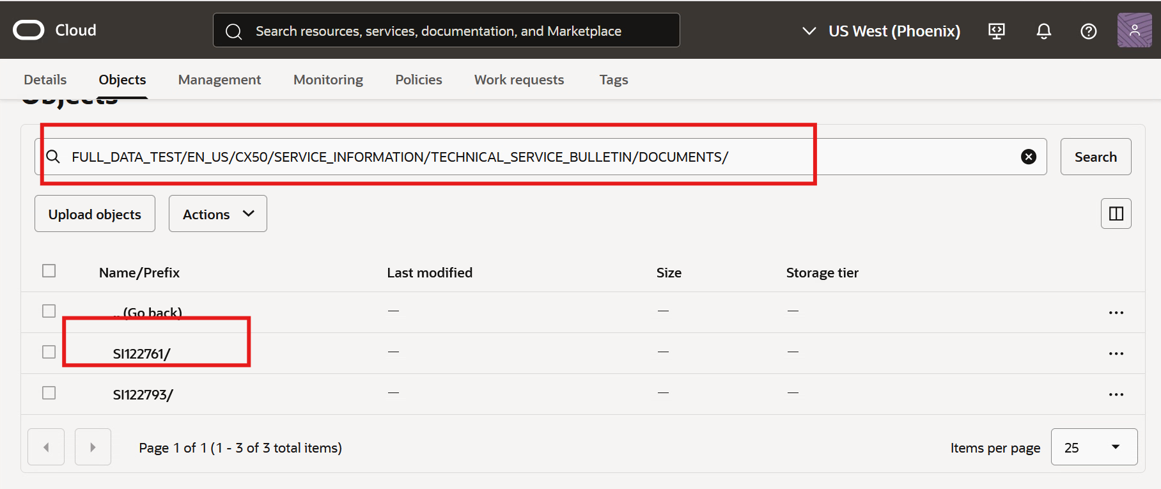
Unpublished in IM for SI document
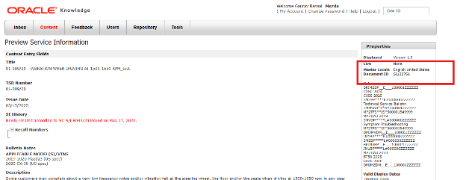

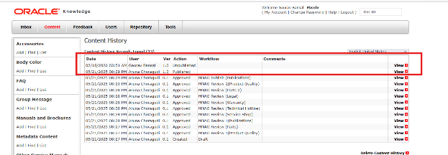
SI122761 document is deleted from OCI storage location
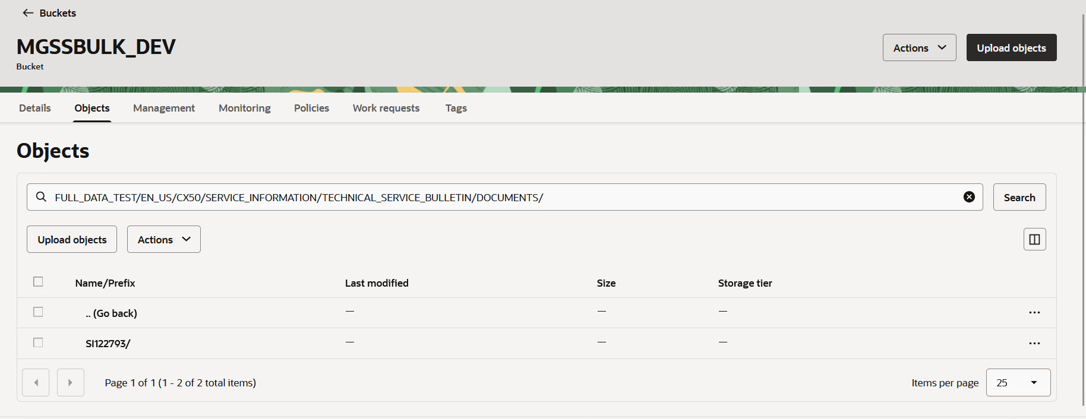

Delete.csv file is generated

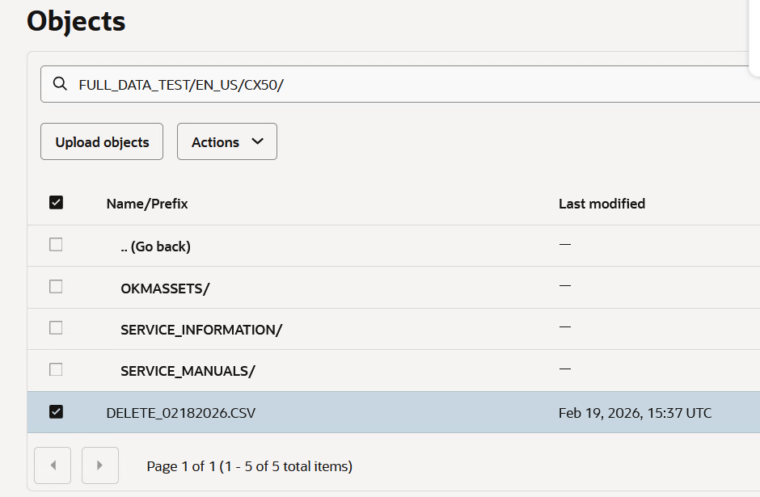

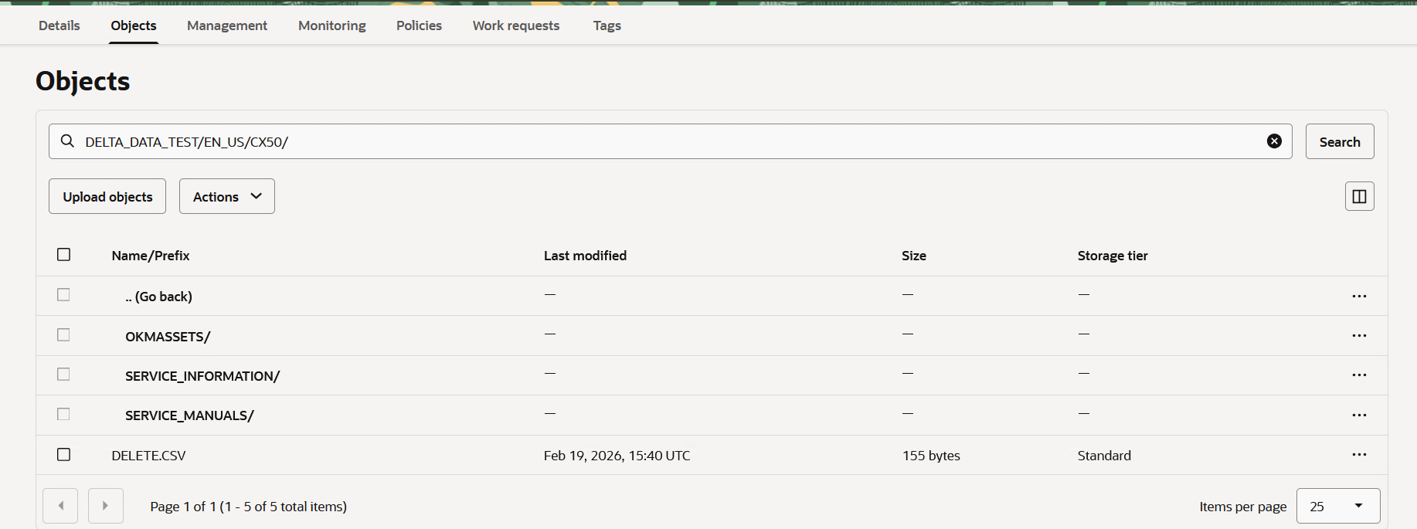
Delete.csv file info:
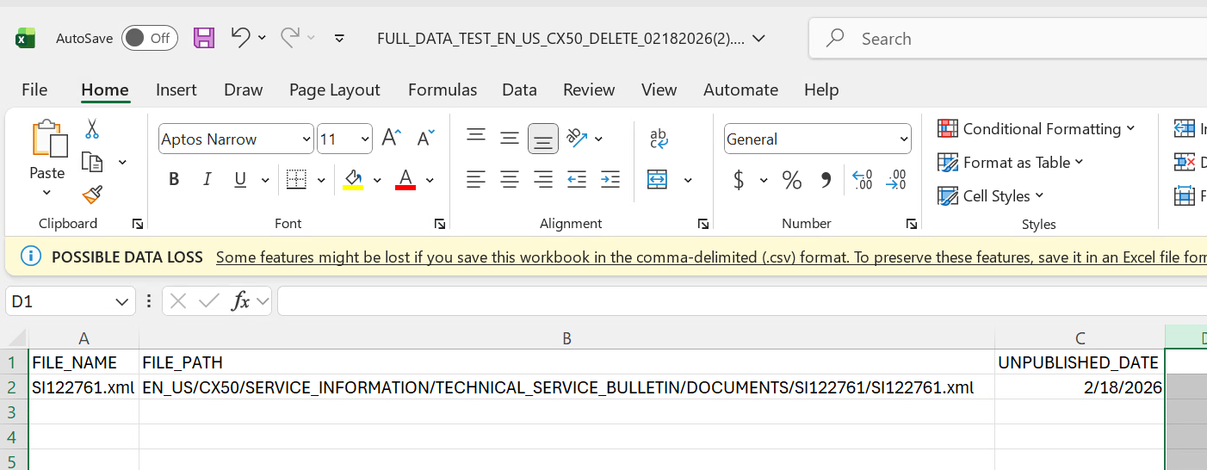

Status: Pass
Remarks:
- If any new model is added in MDM after go-live for en_US locale then Tool will show that model entry with “Last Executed On” with blank value and Schedule time will be similar to other existing model so whenever Auto scheduler will run then Full content will be extracted and transferred on OCI Storage under “Full_Data_Test” and “Delta_Data_Test” folder without delete.csv file.
Expected Result:
Activated MX5 Model in MDM carline module
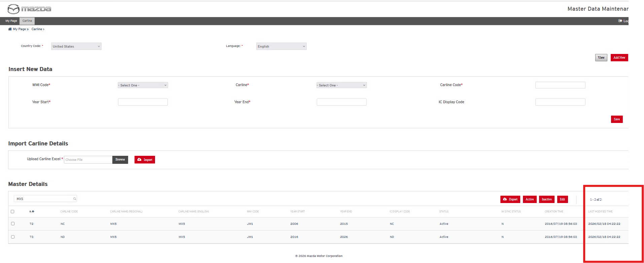

In MGSS Bulk Data export and Transfer Module, MX5 Model appears with default schedule time which was set for other existing models:
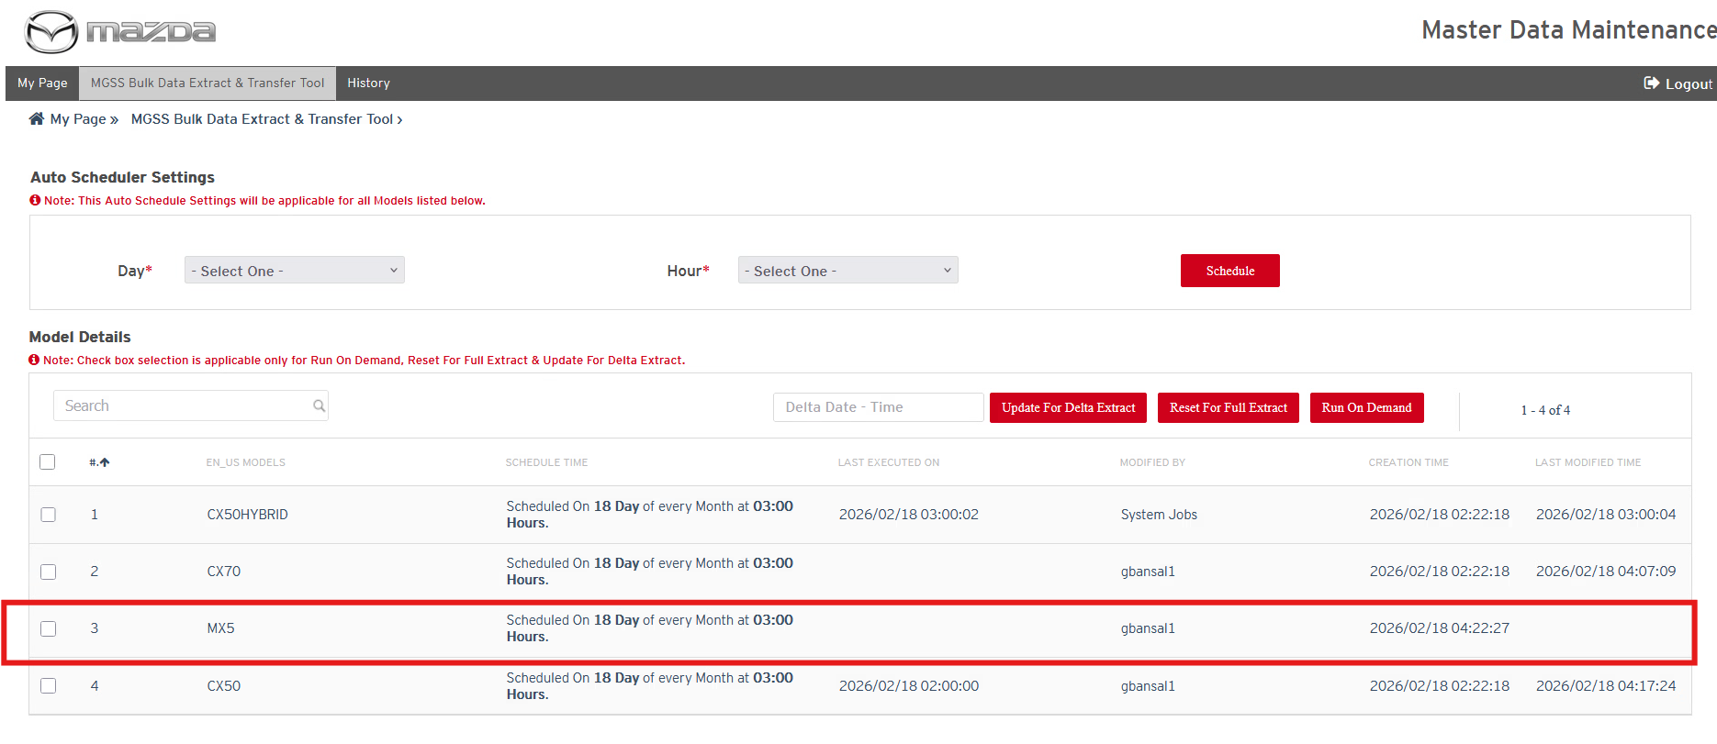
Similar work for CX5, updated CX5 model in carline module and it appeared with default schedule time in MGSS Bulk data export and transfer module:

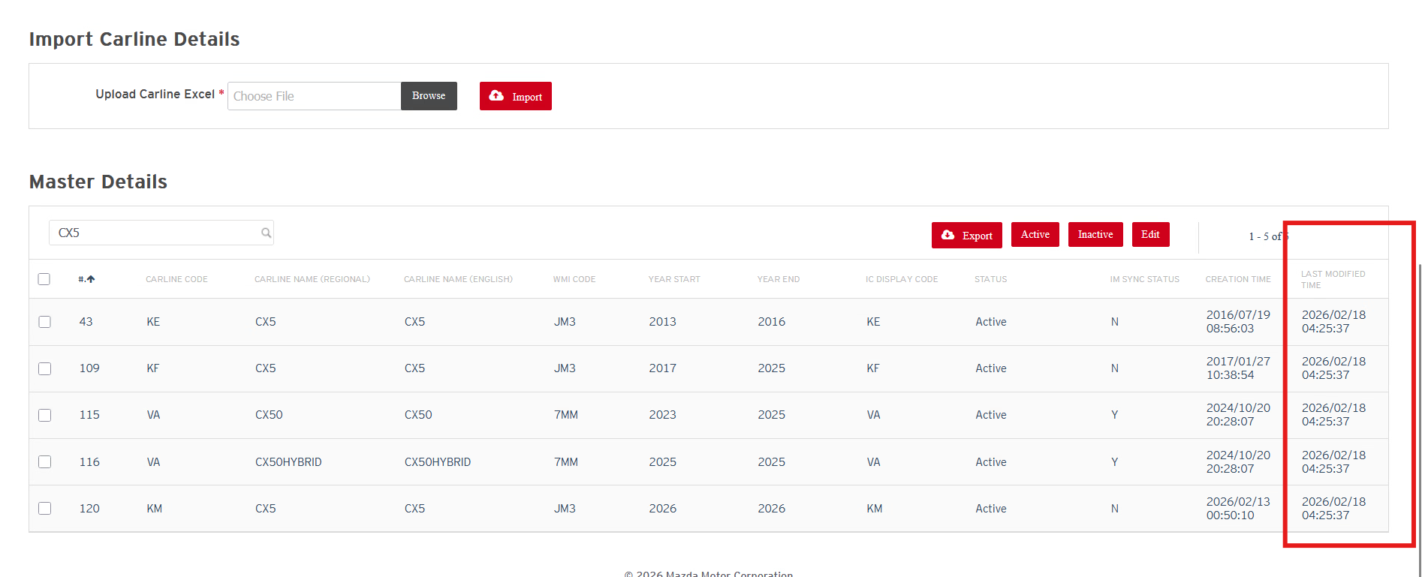
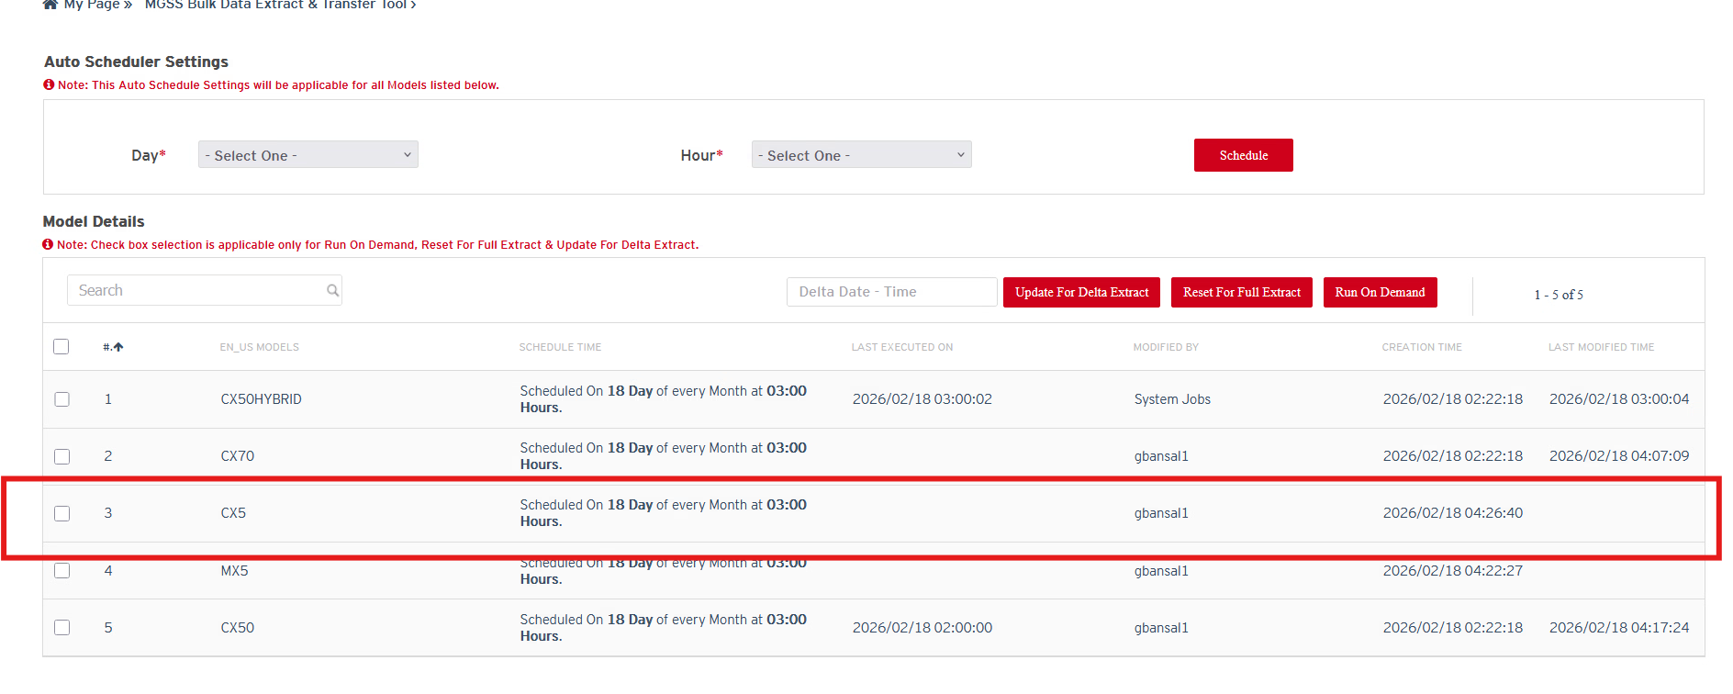

Status: Pass
Remarks:

Run On Demand Job Schedule Process Test Cases

- If user wants to run an on demand job then user should be able to select the one model or more than one model from Model list in “MGSS Bulk Data Extract and Transfer Tool” page and click on “Run On Demand” button.
Expected Result:
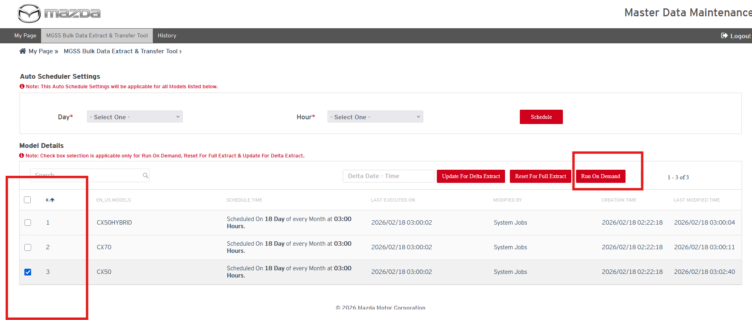
Status: Pass
Remarks:

- Once the on demand job is scheduled then system will take time to start job processing in between 0-5 min. and user should be able to view the message on “MGSS Bulk Data extract and transfer tool” screen as show in below screenshot.
Expected Result:
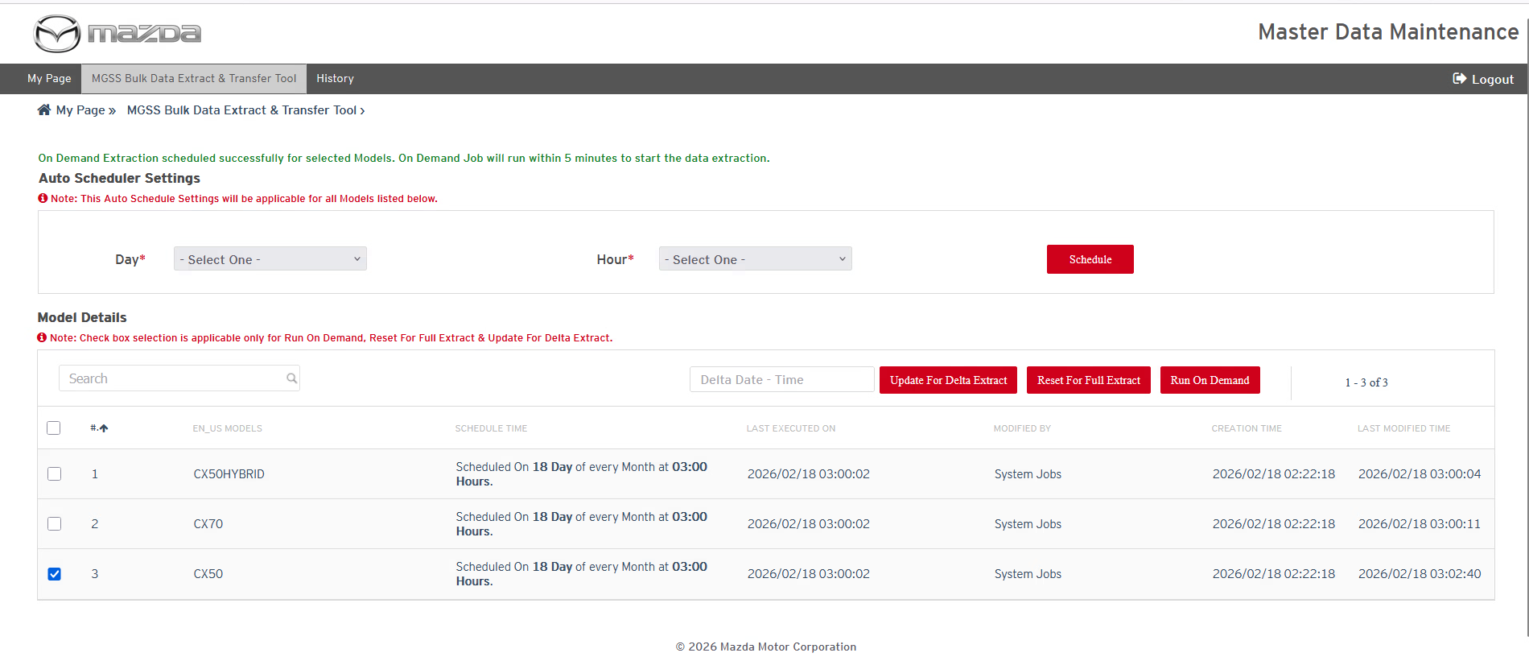
Status: Pass
Remarks:
Note: Rest of the SIT test cases in case of “Run On demand” will be same as mentioned above from SIT.0003 to SIT.0013

Reset Full Data Extract Button Feature
- If user wants to extract the full content anytime of particular selected model anytime in system then user can press the “Rest for Full Data Extract” button and can set the “Last Executed On” timestamp with blank value then Auto scheduler or on Demand schedule should re-extract the full data for that model.
Expected Result:
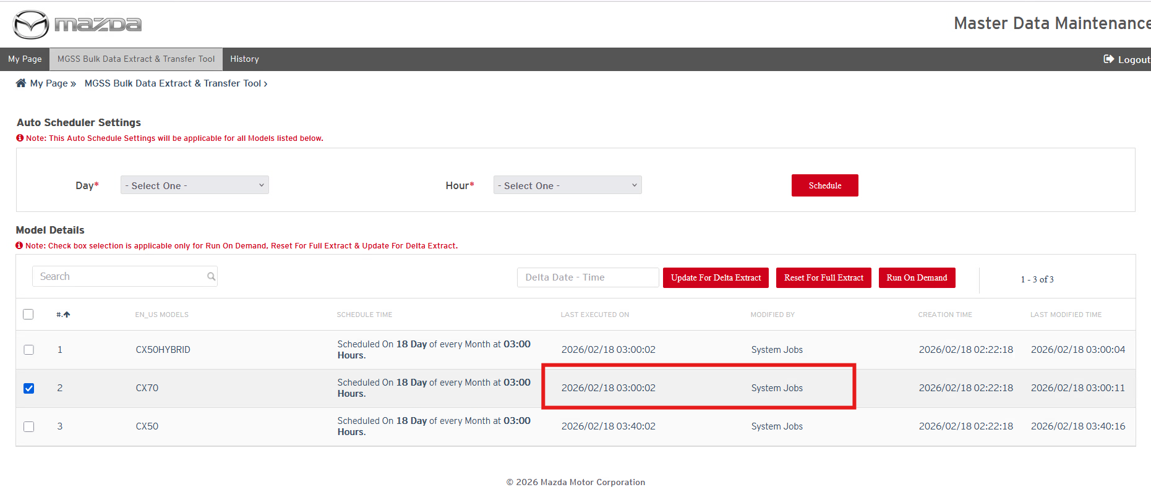
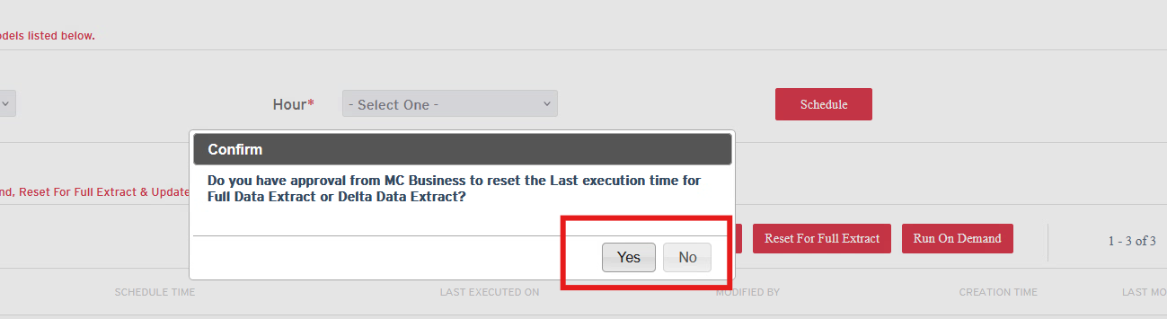
If user click on “Yes”, then it will reset ‘last executed on’ time to blank. If user click on “No” then it will not reset the existing “last executed on” timestamp.
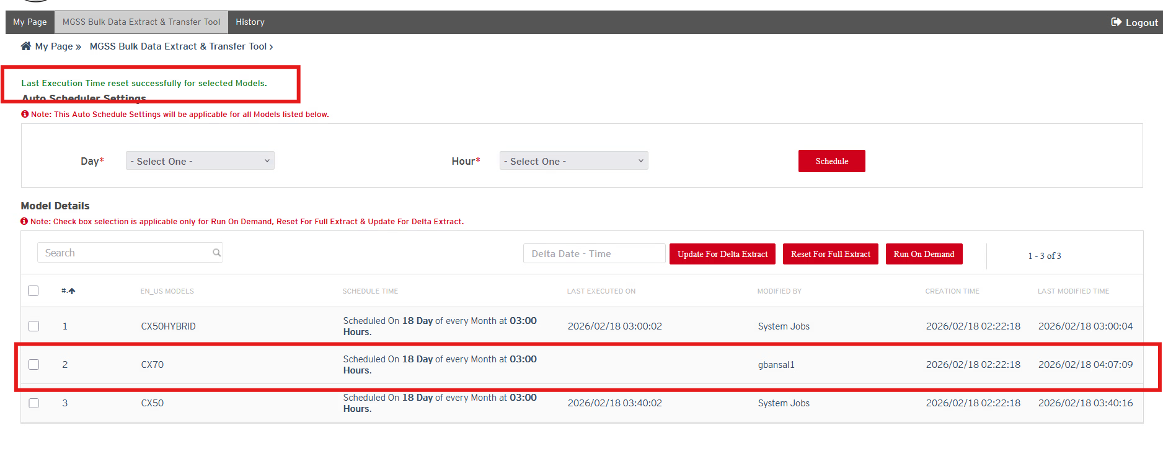
Status: Pass
Remarks:
- If user selects any model which is already in running state in History page and try to reset for full data extract then user should not be allowed to reset the last executed on timestamp and get an error message.
Expected Result:
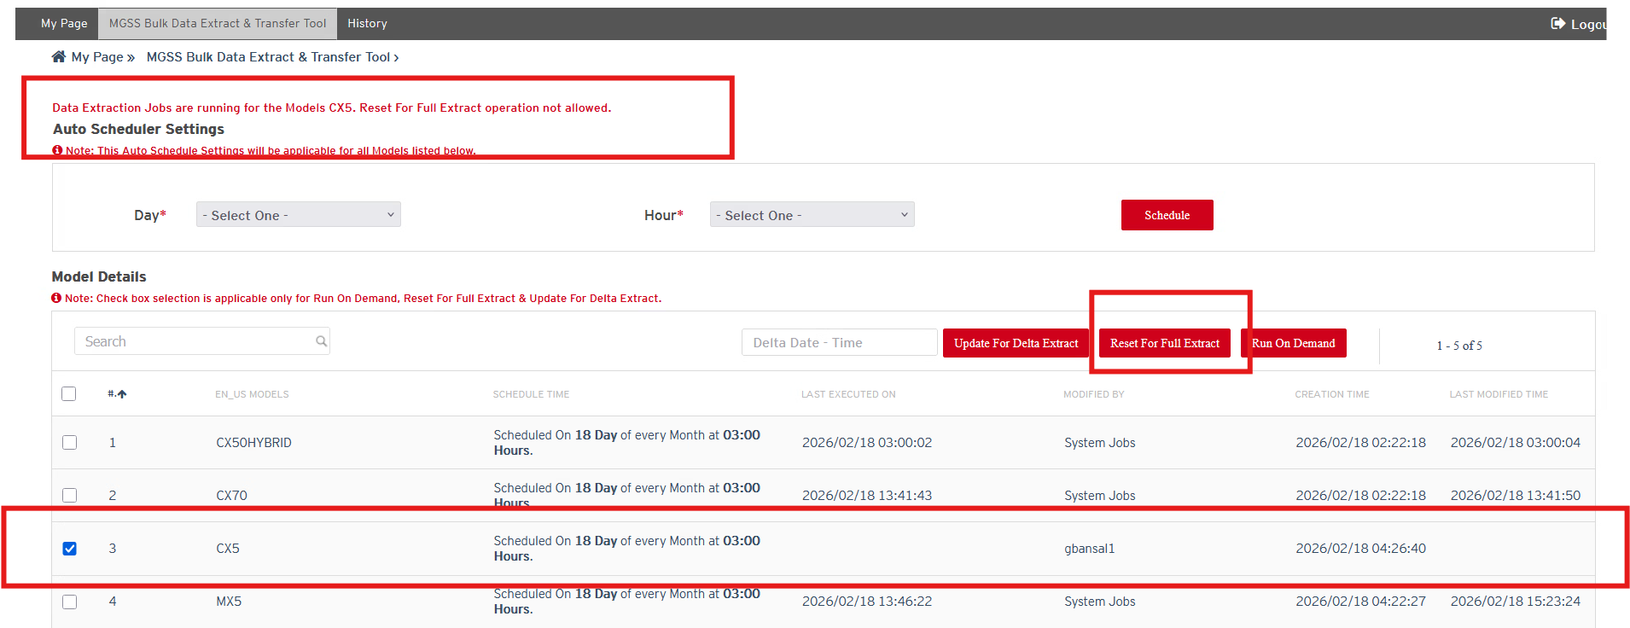

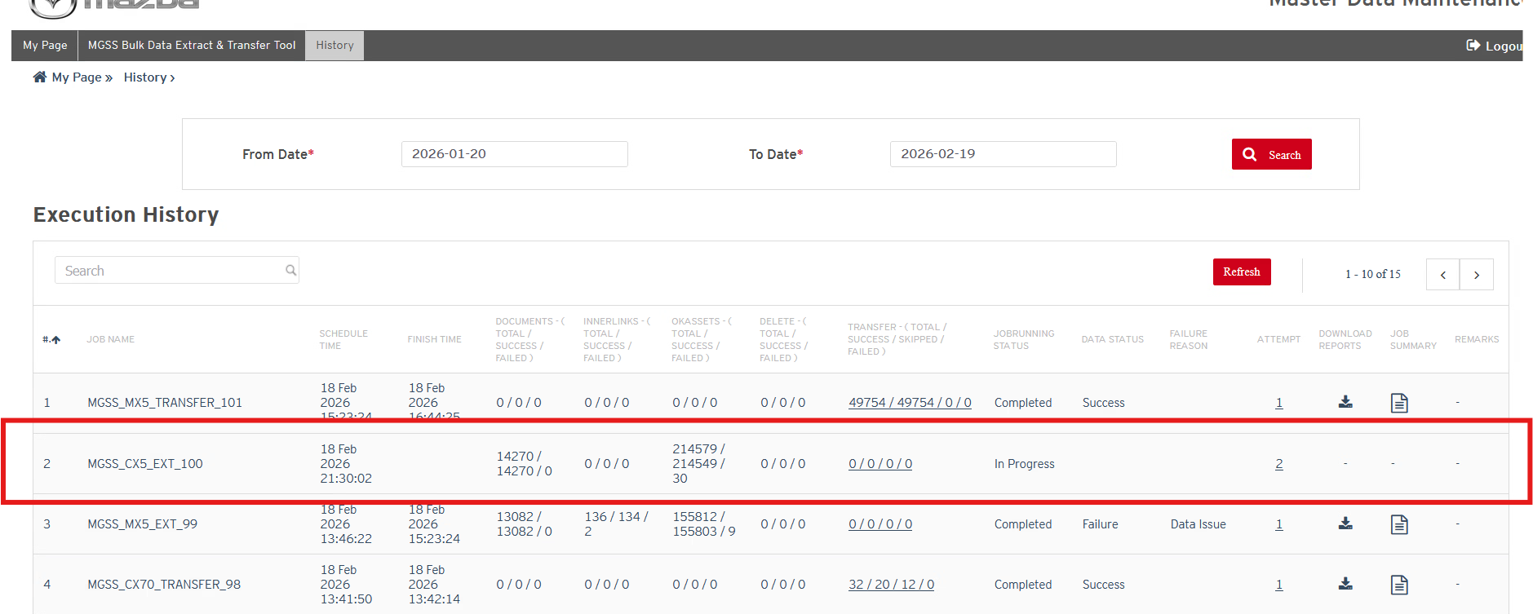
Status: Pass
Remarks:

For Reset Delta Data Update Button Feature
- If user wants to extract the delta data content of particular selected model anytime in system before “Last Executed on“ timestamp then user can press the “Rest for Delta Data Update” button and can set the “Last Executed On” timestamp prior to existing “Last Executed on” value then Auto scheduler or on Demand schedule should re-extract the based on updated “Last Executed On” value in system.
Expected Result:
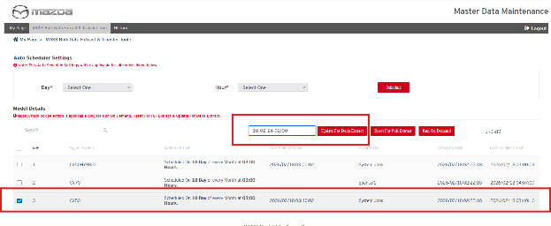
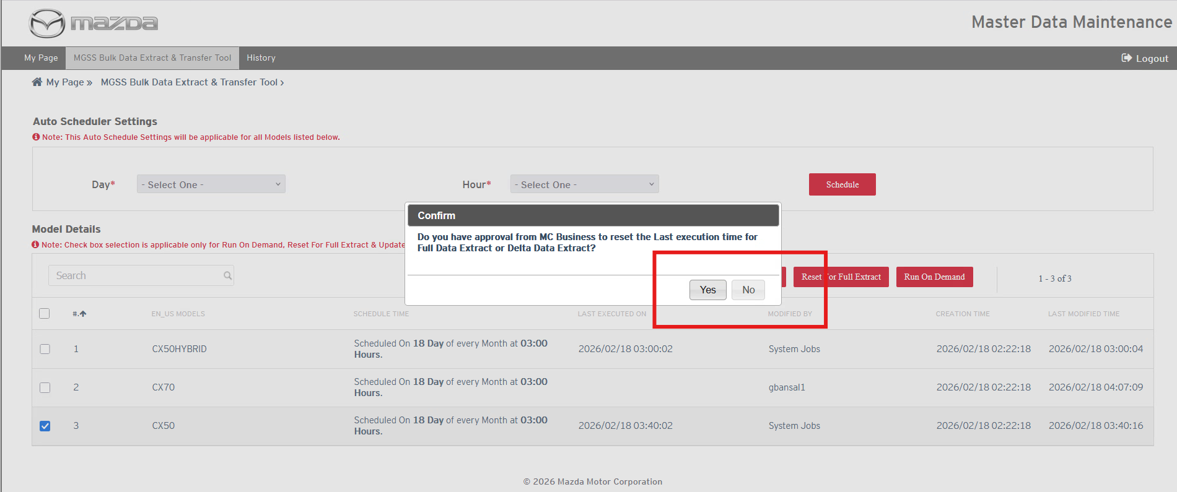
If user click on “Yes”, then it will update ‘last executed on’ time. If user click on “No” then it will not reset the existing “last executed on” timestamp.
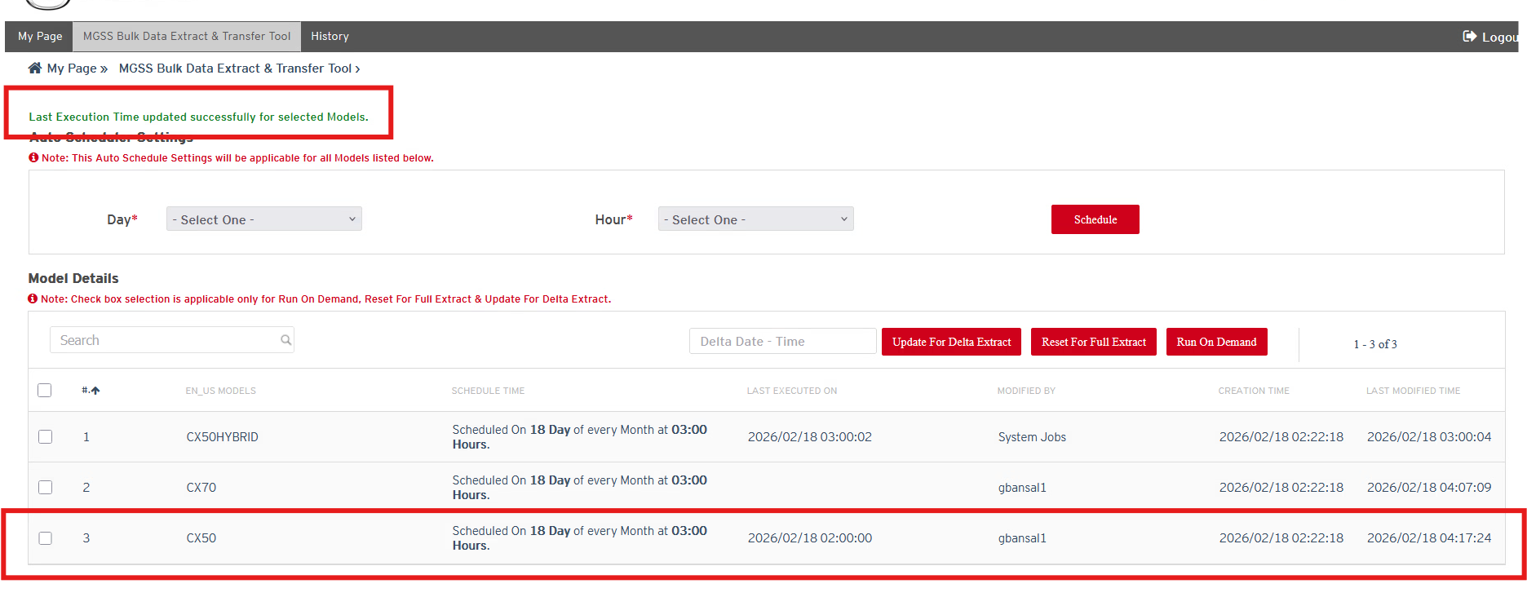

Status: Pass
Remarks:
- If user select any model to reset delta extract time where last executed on time stamp is blank then system will not allow user to reset the delta time.
Expected Result:
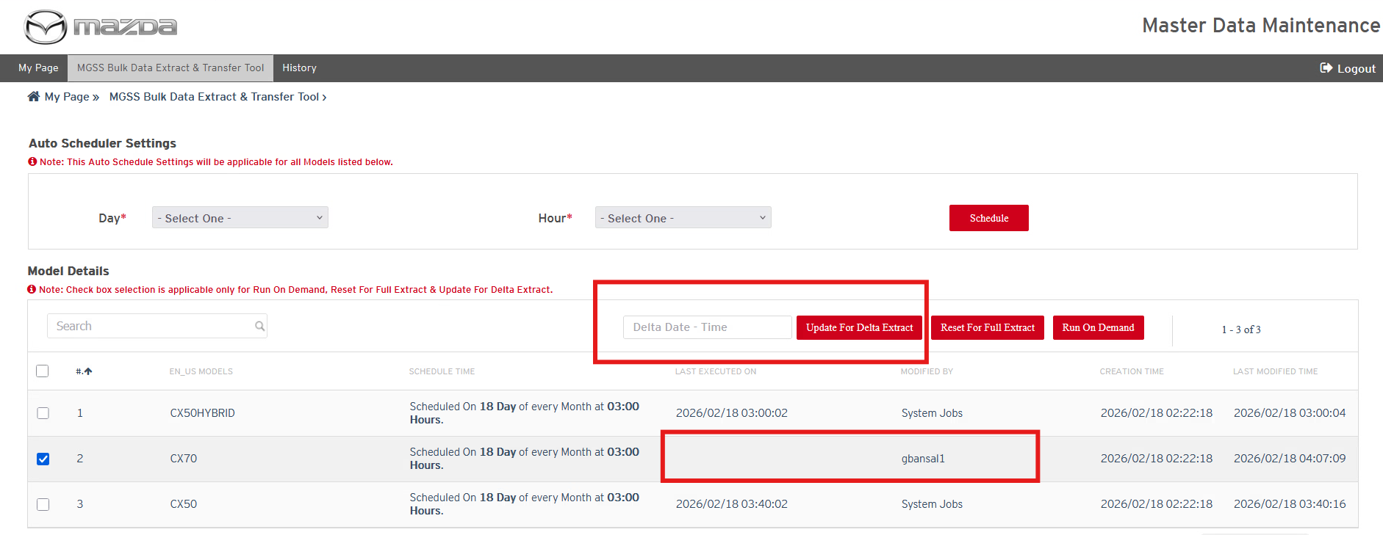
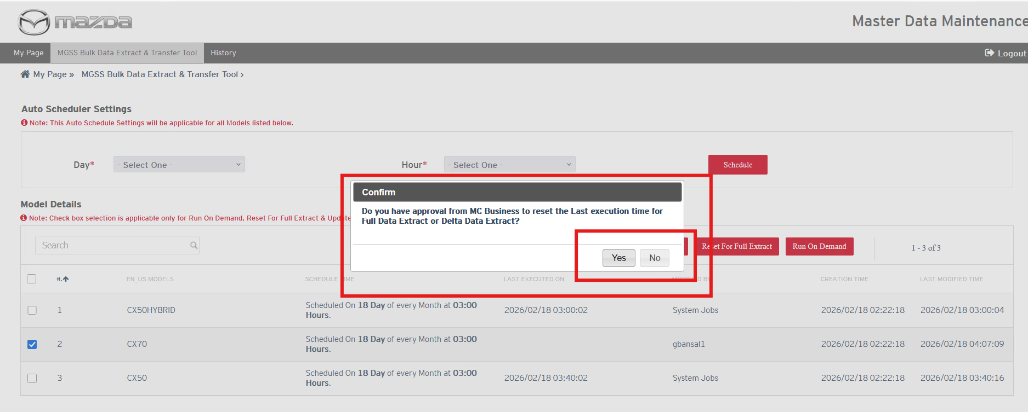
If user click on “Yes”, then it will update ‘last executed on’ time. If user click on “No” then it will not reset the existing “last executed on” timestamp.
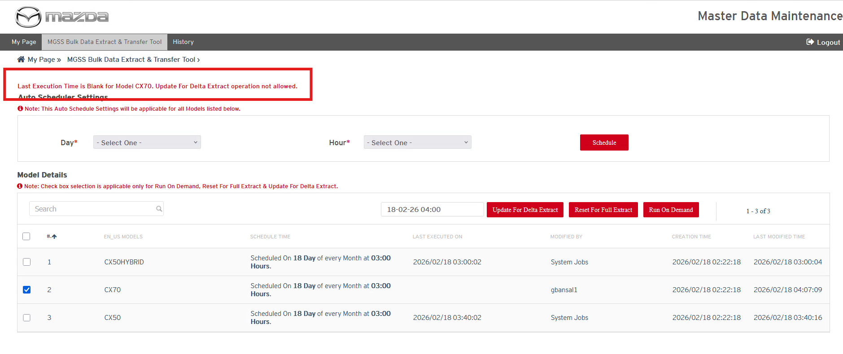

Status: Pass
Remarks:
- If user selects any model to reset delta extract time where data extraction for that model is in running state on history page then user should not be allowed to reset the delta time and should get an error message.
Expected Result:

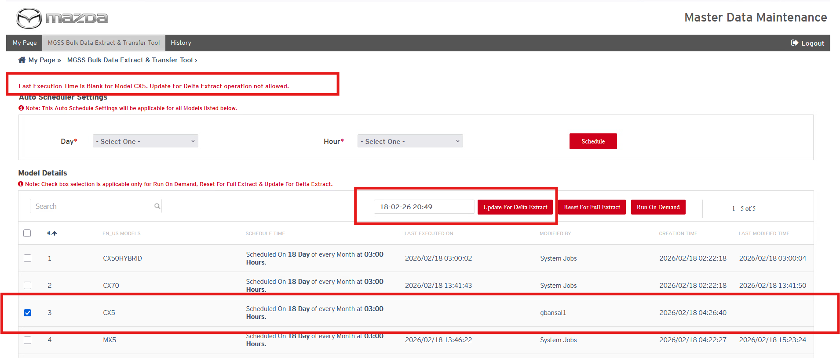

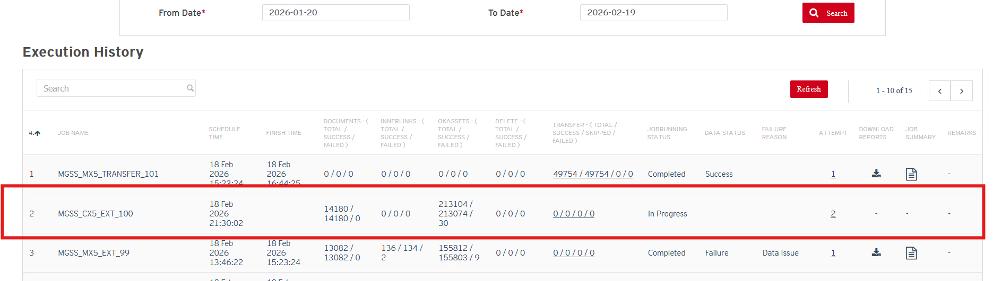
Status: Pass
Remarks:

Bosch Related Test Cases
- Bosch should be able to download the “DELTA_DATA_TEST” Folder from OCI storage. “DELTA_DATA_TEST” folder may contain full data of any model or may contain delta content only as per data extraction and business requirements. After download, Bosch should be able to delete the data from “DELTA_DATA_TEST” Folder on OCI Storage.
Expected Result:
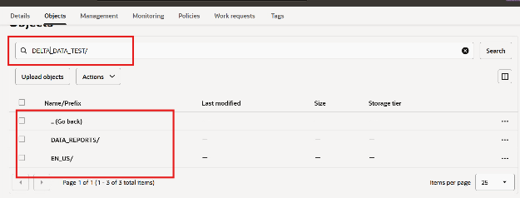

Status: Pass/ Fail
Remarks:

- Bosch should be able to find the “delete.csv” file in “DELTA_DATA_TEST” Content in case any document is unpublished from MGSS. In “delete.csv” file, “File path” column is provided and Bosch should be able to find the document in their “Historical downloaded data from OCI Storage” repository and should be able to delete the files using “File Path” provided in “delete.csv” file.
Note: This test case will be applicable from Delta data content after initial full content extract and transfer.
Expected Result:
File is deleted from “Bosch Downloaded Historical Data” using “delete.csv” file path column value.
Status: Pass/ Fail
Remarks:
- Bosch should be able to confirm whether the downloaded content is parsed, read and usable XML format or not. If any error then let MC team know about that with error details.
Expected Result:
Content should be able to parse and read and in usable XML format.
Status: Pass/ Fail
Remarks:

Content Validation Test Cases
SIT.00024 verify extracted XML attributes for sample documents for SM, WD and SI documents on random basis as per technical design document.
Following is XML schema format which will be extracted for each applicable XML file:
Common Attributes in XML File:
Common Attributes in the XMLs for the all the supported channels (e.g. – Service Manuals, Service Information & Wiring Diagrams)
ATTRIBUTES |  | SERVICE INFORMATION |  | SERVICE MANUALS |  | WIRING DIAGRAMS
MASTERIDENTIFIER | Y |  | Y |  | Y
DOCUMENTID | Y |  | Y |  | Y
LOCALECODE | Y |  | Y |  | Y
VERSION | Y |  | Y |  | Y
CREATEDATE | Y |  | Y |  | Y
LASTMODIFIEDDATE | Y |  | Y |  | Y
PUBLISHEDDATE | Y |  | Y |  | Y
Channel Schema based Attributes
Note: refer below section for more details

- Channel Schema Based Attributes in XMLs:
<SERVICE_INFORMATION>
<TITLE />
<MTIPS_NUMBER />
<TSB_NUMBER />
<TSB_ISSUE_DATE />
<CAMPAIGN_NUMBER />
<BULLETIN_NOTES SECURITY="TECHNICIAN" />
<DESCRIPTION />
<REPAIR_PROCEDURE />
<CALIBRATION />
<PARTS_INFORMATION />
<WARRANTY_INFORMATION />
<FIRST_PUBLICATION_DATE />
<ATTACHMENTS>
<ATTACHMENT_TITLE SECURITY="TECHNICIAN" />
<ATTACHMENT />
<PDF_ATTACHMENTS>
<LEGACY_PDF SECURITY="TECHNICIAN" />
<REVISION_HISTORY />
<OTHER_PDF SECURITY="TECHNICIAN" />
</PDF_ATTACHMENTS>
</ATTACHMENTS>
<EXPIRATION_DATE />
<CAMPAIGN_ATTACHMENTS>
<CAMPAIGN_ATTACHMENT_TITLE SECURITY="CORPORATE" />
<CAMPAIGN_ATTACHMENT SECURITY="CORPORATE" />
</CAMPAIGN_ATTACHMENTS>
</SERVICE_INFORMATION>

<SERVICE_MANUALS>
<TITLE />
<CONTENT />
<ATTACHMENTS>
<ATTACHMENT_TITLE />
<ATTACHMENT />
</ATTACHMENTS>
<DJVU_FILE_LOCATION />
</SERVICE_MANUALS>

<WIRING_DIAGRAMS>
<TITLE />
<NAVIGATION />
<HTML_CONTENT />
<FLASH_CONTENT />
<HTML5_FILE_NAME />
<HTML5_UPLOAD_DIRECTORY />
<HTML5_FONT_SELECTION />
<ATTACHMENT_TITLE />
<ATTACHMENT />
<DJVU_FILE_LOCATION />
</WIRING_DIAGRAMS>

Expected Result: XML file should have above XML nodes in applicable channel documents
Service Manual:

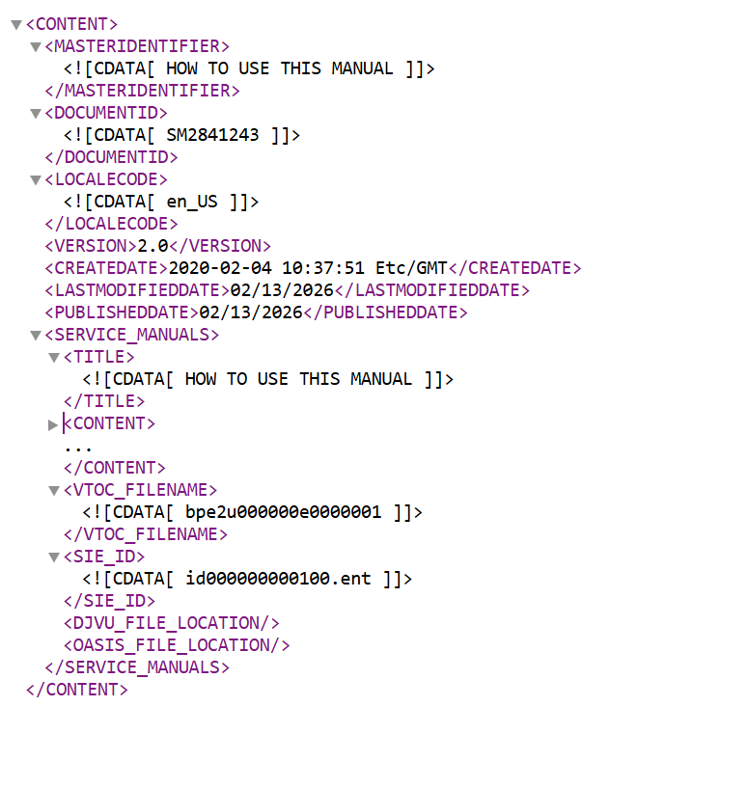

Wiring Diagram:
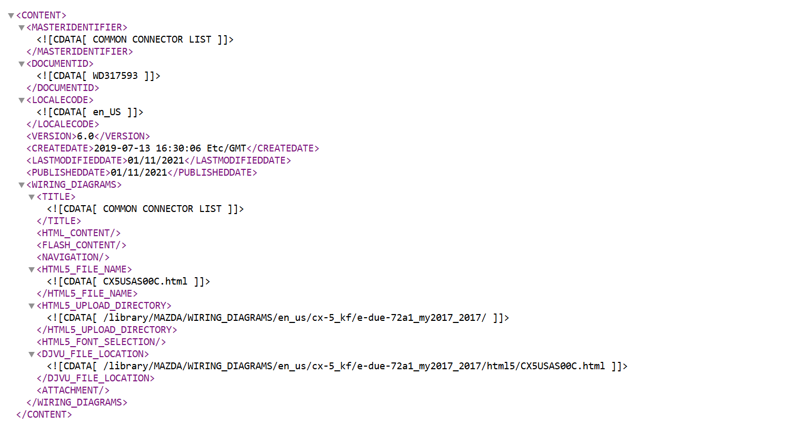

Service Information
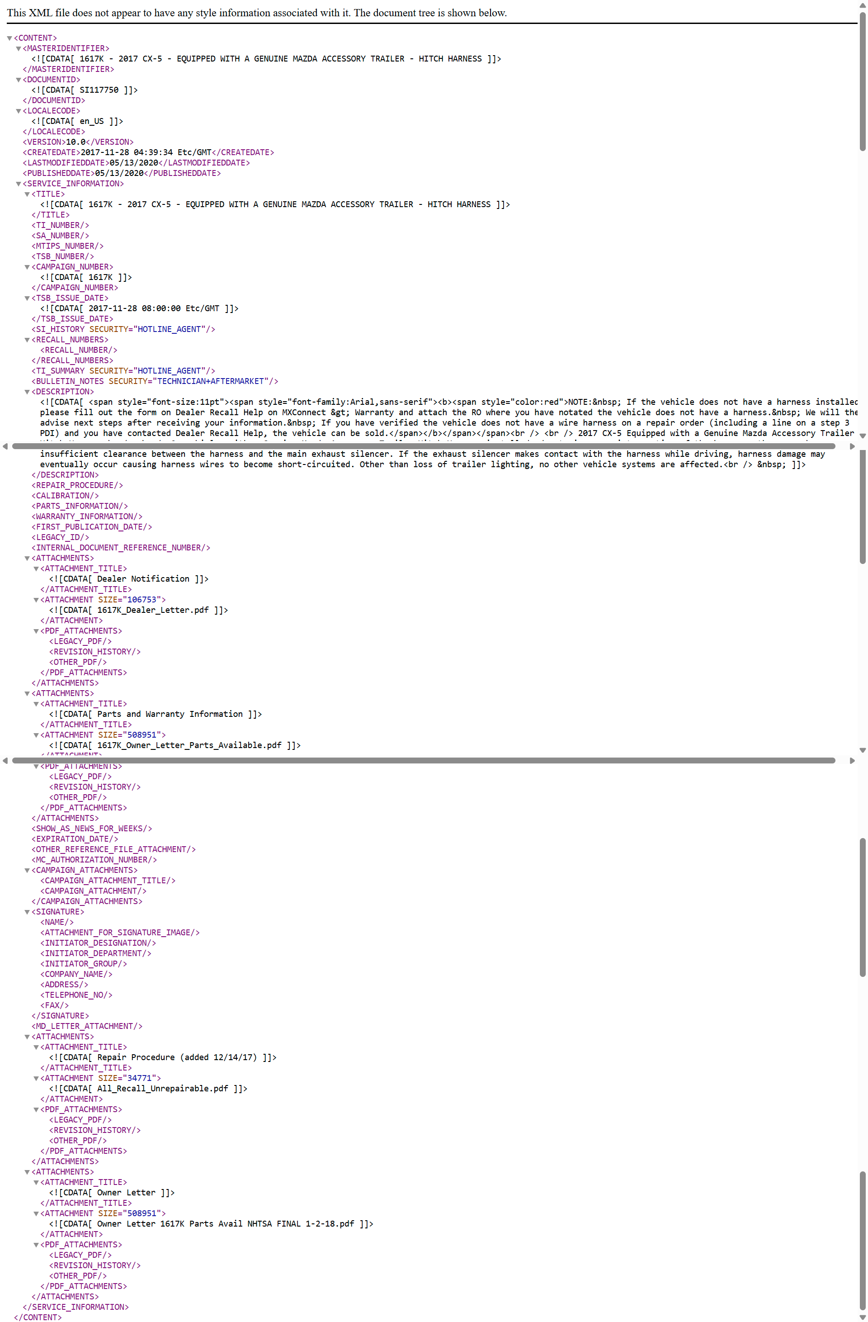
Status : Pass
Remarks:

